Introduction to Coal Ash
Coal ash, or coal combustion residuals (CCR) are one of the largest forms of industrial waste in the United States and are created whenever coal is burned at coal-fired power plants. The U.S. Environmental Protection Agency (EPA) estimates that 130 million tons of coal ash is burned per year, making it the second largest form of industrial waste after household waste. Most coal-burning plants have coal ash disposal on site, which is often a mix of a landfill, pond or silo. The health dangers are heightened when landfills are not covered daily or capped, which leads to unsafe levels of dried ash blowing away from the dumps. Windblown particulates are called “fugitive dust,” which often occurs when ash is loaded, unloaded or transported.

Coal ash byproducts may include the following: 1) fly ash, a very fine, powdery material composed mostly of silica made from the burning of finely ground coal in a boiler; 2) bottom ash, a coarse, angular ash particle that is too large to be carried up into the smoke stacks so it forms in the bottom of the coal furnace; 3) boiler slag, molten bottom ash from slag tap and cyclone type furnaces that turns into pellets that have a smooth glassy appearance after it is cooled with water; 4) flue gas desulfurization material, a material leftover from the process of reducing sulfur dioxide emissions from a coal-fired boiler that can be a wet sludge consisting of calcium sulfite or calcium sulfate or a dry powered material that is a mixture of sulfites and sulfates.

Of these four categories, fly ash makes up the largest percentage by weight. Fly ash is the lightest form of coal ash and it is the most likely to become airborne. Two factors that dramatically increase the risk from disposal units are the use of wet surface impoundments instead of dry landfills, and whether disposal units have composite liners to prevent leaking and leaching. Surface impoundments (the wet ash ponds) consistently show higher risks than landfills. The arid climate of the Four Corners region creates a particular challenge since the coal ash dries rapidly and is largely uncontained.

Environmental and Health Effects of Coal Ash
Exposure to the toxic chemicals found in coal ash present a serious threat to public health that could lead to severe injury and even death in some cases. People become exposed to coal ash through a variety of means. It is possible to breathe in fugitive dust that contains airborne coal ash that contains a multitude of toxic contaminants. This can come from an uncovered dump site, the back of an open truck, or in local rivers, lakes, streams or nearby forests. The EPA has found that if you live near an unlined wet ash pond (surface impoundment) and you get your drinking water from a well, you may have as much as a 1 in 50 chance of getting cancer from drinking arsenic-contaminated water.

There are multiple coal ash pollutants that lead to a variety of health impacts that we know about. Studies have linked coal-derived particulates, including those from fly ash, to the four leading causes of death in the US: heart disease, cancer, respiratory diseases and stroke. Below is information about specific contaminants and how their various negative health effects:

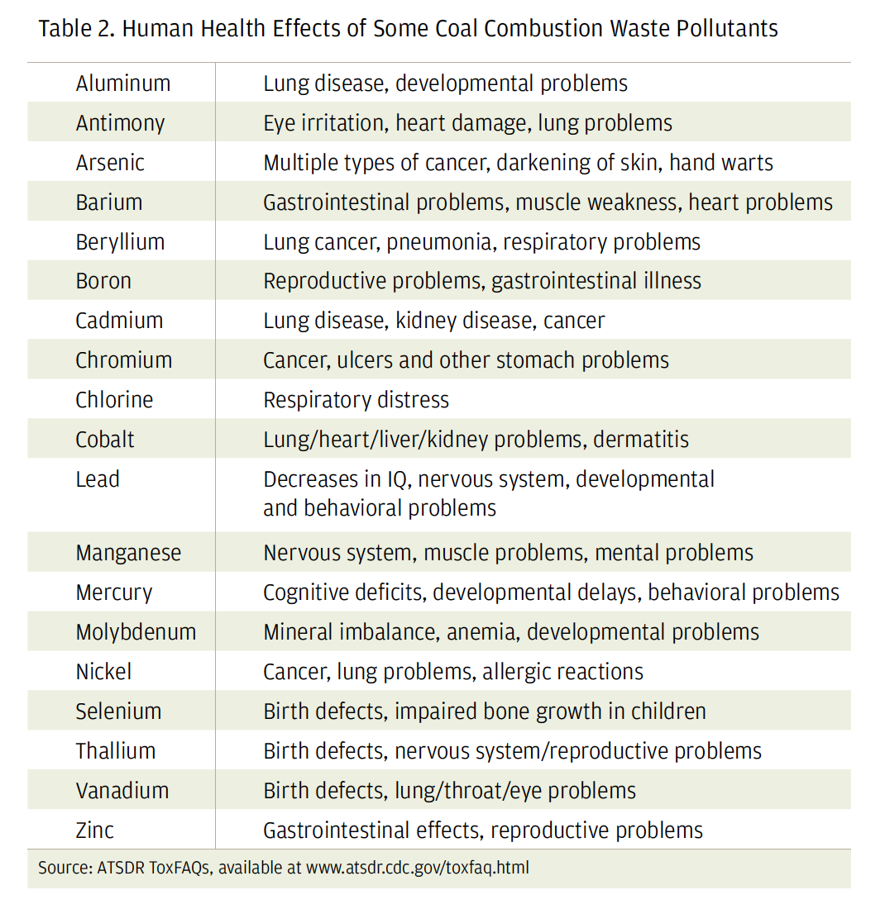
Source: ATSDR ToxFAQs

For decades, coal ash has polluted fragile ecosystems pollutants traveling through rivers, streams, lakes and reservoirs. Coal ash toxins that bioaccumulate such as arsenic, cadmium, chromium, lead, mercury and selenium have led to fish kills, deformities in fish and amphibians. Three main toxins that are commonly found in coal ash are arsenic, methyl mercury and selenium.

Regulatory Framework Highlights

CCR Rule
The primary law that regulates coal ash is the Coal Combustion Residuals (CCR) Rule. Under this rule, beginning in 2018 coal-fired electric utilities had to follow transparency requirements and publicly report groundwater monitoring data for the first time. Earthjustice and the Environmental Integrity Project (EIP)’s comprehensive coal ash contamination map aggregates industry disclosures posted on individual owner/operator websites as it relates to the 2015 CCR Rule. This data describes the status of groundwater monitoring and whether the operator has found groundwater contamination from coal ash. It was found that 91% of the 265 coal plants with groundwater monitoring data are contaminating groundwater with toxic substances that exceed safe levels. Earthjustice has published a very useful toolkit to help communities hold coal operators accountable regarding the CCR Rule.

Clean Water Act
The Clean Water Act (CWA) establishes the basic structure for regulating discharges of pollutants into the waters of the United States and regulating quality standards for surface waters. The CWA made it unlawful to discharge any pollutant from a point source into navigable waters, unless a permit was obtained, which is run by the EPA's National Pollutant Discharge Elimination System (NPDES) permit program.

In April, 2020 the Supreme Court ruled on the County of Maui v. Hawaii Wildlife Fund, and created the “functional equivalent” test intended to help determine if a Clean Water Act permit is needed when pollutants are discharged to groundwater before reaching navigable waters. Under this new test, a discharge is “functionally equivalent” to a direct discharge if it “reaches the same result through roughly similar means.” This could have important implications for the Navajo Nation where it is common for “navigable body of water” such as the San Juan river, to be connected to a coal plant through groundwater channels (arroyos, washes) through which pollutants can be discharged.

Other relevant federal regulations that are relevant include Resource Conservation and Recovery Act (RCRA), which regulates open dumps, and the National Environmental Policy Act (NEPA) and The Endangered Species Act (ESA) which together aim to protect threatened species.

Navajo Nation Coal Plant Profiles and Recommendations

Four Corners Power Plant
Four Corners Power Plant (FCPP) is a 1,540 megawatt coal-fired power plant, and one of the biggest coal-fired power plants in the West. FCPP began operations in 1963 and it set to close in 2031. It has a closure plan which describes how this will happen. There have been about 84 million tons of CCRs that have been dumped in unlined wet impoundments, a “dry” landfill, and dumped off site in abandoned mine pits of the Navajo Mine. Many concerns have been raised that this activity violates the open dumping prohibition of the Resource Conservation and Recovery Act (RCRA).

The following table summarizes the contaminants above EPA drinking standards across the different units at FCPP obtained from CCR compliance data.

Table: FCPP contaminants above EPA drinking standards
 | Arsenic | Boron | Chromium | Fluoride | Lead | Molybdenum | Radium | Selenium | Sulfate | Cobalt | Lithium
Lined Ash Impoundment | x1 | x42 | x1 | x5 | x2 | x4 | x5 | x2 | x21 | n/a | n/a
Lined Decant Water Pond | x1 | x42 | x1 | x5 | x2 | x4 | x5 | x2 | x21 | x45 | x20
Upper Retention Sump | x1 | x42 | x1 | x45 | x2 | x4 | x5 | x2 | x21 | x45 | n/a
The Combined Waste Treatment Pond | x1 | x42 | x1 | x5 | x2 | x4 | x5 | x2 | x21 | n/a | n/a

All CCRs disposed prior to the 2015 CCR Rule in “closed” on-site wet impoundments have been abandoned in place, with only minimal engineering controls installed to limit the generation and escape of groundwater contamination from those units. APS has repeatedly stated their intent to close in place some active CCR units, beginning as soon as fall 2020.

Recommendations
- Ensure a CCR Rule public meeting takes place and be prepared.
The most recent CCR Compliance report is APS’ January 2021 Annual Inspection Report. Under 40 CFR §257.96(e), APS must conduct a public meeting with interested and affected parties to present the results of the Assessment of Corrective Measures (ACM) for Multiunit 1 and the Upper Retention Sump (URS) at least 30 days prior to selecting remedies for each. The July 15, 2020 Remedy/Semiannual Report notes that public meetings are delayed due to COVID-19. This community meeting must happen, and the community should be fully prepared to have this meeting required under the CCR Rule.

To meet the requirements of 40 CFR §257.91(f), APS will begin remedial activities at Multiunit 1 and the URS within 90 days of selecting a remedy for each unit. According to the annual report, closure activities at Multiunit 1 will be initiated and continue at the CWTP in 2021 in accordance with the individual unit closure plans.

All CCRs disposed prior to the 2015 CCR Rule in “closed” on-site wet impoundments have been abandoned in place, with only minimal engineering controls installed to limit the generation and escape of groundwater contamination from those units. APS has repeatedly stated their intent to close in place some active CCR units.

- Explore legal options under the Clean Water Act.
It’s possible that the “functional equivalent” precedent set by the County of Maui v. Hawaii Wildlife Fund case could trigger the Clean Water Act through the Chaco Wash as a groundwater pollutant pathway.

- Follow how PNM’s ownership transfer to NTEC will affect closure plans and liability.
In January 2020, Arizona Public Service announced it would be decommissioning the Four Corners Generating Station ahead of schedule by the end of 2031, instead of waiting until 2038. APS is the primary owner but in January 2021, PNM filed with the NMPRC to transfer its 13% ownership to Navajo-owned NTEC (which previously owned 7%), which could alter closure plans including financial liability.

- Continue legal remedies over potential RCRA violations.
For more than thirty years fly ash, bottom ash and scrubber sludge from the Four Corners Power Plant was placed in unlined impoundments and backfilled into the Navajo Mine, which has supplied coal to the plant since 1968. APS has already stored 50 to 55 million tons of coal ash in unlined pits near the San Juan River and more recently are believed to be storing it in stockpiles.

San Juan Generating Station
San Juan Generating Station is a coal-fired electric power plant sourced by the San Juan Mine. In 2017, Units 2 and 3 (369 and 555 MW, completed in 1976 and 1979, respectively) were retired. Units 1 and 4 (also 369 and 555 MW, completed in 1973 and 1982, respectively) are scheduled to shut down in 2022, although there are attempts to retrofit the power plant and keep it open.

Coal ash generated at the San Juan Generating Station (SJGS) is returned to the adjacent mines for use in reclamation, so this station does not have or utilize ash impoundments or landfills, and therefore there is no CCR compliance data or requirements.

In a national analysis from Earthjustice that identifies known drinking water contamination (different from the mandatory CCR groundwater reporting data), contaminants were found in the drinking water at SJGS. In Earthjustice’s Waste Deep report, arsenic, boron, lead, sulfates and selenium were found in an unlined pond. Since the late 1980s, 40 million tons of coal combustion waste have been dumped in the San Juan Mine. This has poisoned the shallow groundwater and surface water in the Shumway Arroyo. Levels of lead, selenium, arsenic, cadmium, and boron have risen above drinking water standards in the shallow gravel aquifer below the arroyo.

At the boundary of the San Juan mine, sulfates in the aquifer have reached 55,000 milligrams per liter (mg/L), which is 220 times the secondary drinking water standard. Total dissolved solids can be an indicator of all pollution in water and were found exceeding 80,000 mg/L, which is 160 times the federal standard. The Shumway Arroyo, which was previously a drinking water source for residents and their livestock, has been poisoned by coal ash.

Although PNM lined its ash disposal site ponds in response to 1984 EPA changes, the dumping of coal combustion waste in unlined sites accelerated afterwards. PNM required San Juan Mine (its main coal supplier) to backhaul more of PNM’s coal ash to the mine’s pits. Since 1987, The San Juan Mine has been filling more than 20 pits with CCW, ranging from a few acres to hundreds of acres in size. Large unlined pits, nearly 200 feet deep and 300 feet wide are now filled with concentrated, battleship-sized tonnages of caustic fly ash and scrubber sludge. Since the pits are located above the arroyo, CCW continues to poison the groundwater.

In July 2019, PNM submitted its closure plan for SJGS.

Recommendations
- Explore legal options under the Clean Water Act.
It’s possible that the “functional equivalent” precedent set by the County of Maui v.
Hawaii Wildlife Fund case could trigger the Clean Water Act through the Shumway Arroyo as a groundwater pollutant pathway.

- Follow how the PNM/Avangrid merger will affect closure plans.
This is being considered in depth under the New Mexico Utility Commission under filing 20-00222-UT. This will affect financial liabilities including reclamation bond release.

Navajo Generating Station
Navajo Generating Station (NGS) is a 2.25-gigawatt coal-fired power plant that closed in November, 2019. NGS and the associated Kayenta Mine Complex (KMC) has one coal ash landfill for the retired plant. Most of the coal ash produced by NGS was disposed of 1.5 miles east of the plant at a dedicated landfill totaling 765 acres..

This landfill contains about 20 million tons of coal ash and will be closed in place. NGS does not have a hazard rating since disposal requirements only apply to surface impoundments, not landfills. EPA Data did not show any pollutants present at unsafe levels for drinking water. SRP claims that over 90% of the decommissioned plant will be recycled and the most recent closure plan is here with a public comment date that ended April 15, 2021.

Recommendations
- Explore the issue of N Aquifer being contaminated.
The one landfill at NGS is regulated by the CCR Rule. Salt River Power (SRP) posted an Alternative Source Demonstration for contamination, so there is no clean-up plan for the site, but this does not mean coal ash contamination did not take place. The Carmel geological formation that NGS is located upon did not contain groundwater prior to operation of the NGS plant, and now there is a “new” aquifer.
Within the relatively thin Carmel Formation, there is a shallow zone of groundwater that is exposed or very near the land surface at the NGS plant. A major regional groundwater (aquifer) system (N Aquifer) is in the massive Navajo Sandstone located beneath the Carmel Formation. Monitoring of groundwater distribution and quality in the Carmel Formation is occurring, even though there should be no such groundwater since the NGS is a zero liquid discharge (ZLD) facility and the DEIS reports that the Carmel Foundation was “dry” prior to building the power plant. Unintentional leakage of industry-impacted water from this ZLD facility has formed a “new” aquifer in the Carmel Formation, and groundwater is now located as littles as five feet below the NGS plant.

- Monitor the bond release process.
In May 2019, Peabody did, for the first time in more than 40 years of mining at Kayenta, apply for bond release for full reclamation on 1,384 acres, just 10% of the disturbed land. Although Peabody touts its “contemporaneous approach” to reclamation, as of August 26, 2019, the day the mine officially closed, no lands at Kayenta Mine had yet been certified by OSMRE to be fully reclaimed.

Cholla Power Plant
Cholla Power Plant is a 1,021 MW coal-fired power plant that is owned primarily by APS and it began operating in 1962. Unit 2 retired in October 2015, Unit 4 retired in December 2020, and Units 1 and 3 are scheduled for retirement before the end of 2025.Coal burned at the plant was previously sourced from the McKinley Mine in New Mexico. When the McKinley Mine closed in 2009, the source of coal switched to the Lee Ranch and El Segundo mines near Grants, New Mexico. Plant infrastructure includes four single CCR units referred to as the Fly Ash Pond (FAP), Bottom Ash Pond (BAP), Bottom Ash Monofill (BAM), and Sedimentation Pond (SEDI).

Table: Cholla Power Plant contaminants above EPA drinking standards obtained from CCR compliance data
 | Arsenic | Boron | Cobalt | Fluoride | Lithium | Molybdenum | Radium | Selenium | Sulfate
Bottom Ash Pond | x3 | x12 | x8 | x1 | x17 | x9 | x2 | x2 | x23
The Fly Ash Pond | x3 | x12 | x8 | x1 | x17 | x9 | x2 | x2 | x23
SEDI unit | x3 | x12 | x8 | x1 | x17 | x9 | x2 | x2 | x23

Recommendations
- Ensure a public meeting takes place under the CCR Rule.
Under the CCR Rule 40 CFR §257.96(e), APS must conduct a public meeting with the interested and affected parties to present the results of the Assessment of Corrective Measures for the Fly Ash Pond and the Bottom Ash Pond that meet the requirements of 40 CFR §257.97(b). Additionally, APS will prepare a remedy selection report for each unit per 40 CFR §257.97(a).

- Follow up on the EPA review and ensure the comment period is adhered to.
In November, 2020, APS submitted a demonstration per 257.103(f)(2) [Permanent Cessation of a Coal-Fired Boiler(s) by a Date Certain] for the Bottom Ash Pond and the Fly Ash Pond, seeking to move complete closure dates to 10/17/2028. The EPA has been reviewing the application to determine whether it is complete. If the EPA moves forward with implementing the Part A Rule as issued, it would first reject any incomplete applications, then review the complete ones on the merits and issue proposed decisions with a comment period ranging from 15-30 days. EPA’s regulations call for final decisions within four months of completeness decisions.

Escalante Generating Station
Escalante Power Plant was a 253 MW coal-fired generating station that closed it’s sole unit, Unit 1 in November, 2020. Escalante power plant contains one unit that is a CCR landfill. The plant generates fly ash, bottom ash, and flye gas desulfurization (FGD) and disposes these materials in the facility. Filling began at the facility in 2009, and CCRs have been deposited over approximately 24 acres to date.

This landfill contains the following levels of contaminants above drinking water standards: Arsenic (x2), Lithium (x15). This unit contains about 800,000 tons of coal ash and does not have aquifer requirements.

Recommendations
- Ensure that the proper process of the CCR Rule is adhered to.
There is no published clean up plant for site. The most current reports are the 2020 Annual Report and the 2020 Annual Inspection Report.

Technical Memorandum Regarding Hydrological Impacts from the Disposal of Coal Combustion Residuals (CCRs) at Four Corners Power Plant, New Mexico, Navajo Nation.” 2020. Steve Campbell, PhD.
“Evaluation and Professional Opinions Regarding Geological and Hydrogeologic Aspects of the 2016 Draft Environmental Impact Statement as it Pertains to Scheduled Facility Closure in 2019 or Extending Operation Until 2044.” 2017. Groundwater Management Associates.

