Health and Environmental Effects of Coal Ash
December, 2020

Introduction to Coal Ash
Coal ash, or coal combustion residuals (CCR) are one of the largest forms of industrial waste in the United States and are created whenever coal is burned at coal-fired power plants. The U.S. Environmental Protection Agency (EPA) estimates that 130 million tons of coal ash is burned per year, making it the second largest form of industrial waste after household waste. Roughly one quarter of coal ash is stored in wet impoundments, often referred to as “ponds”- some are as large as 1,000 acres. The remaining coal ash is used in industrial applications, including large-scale disposal such as structural fill projects and filling mines with coal ash. Most coal-burning plants have coal ash disposal on site, which is often a mix of a landfill, pond or silo. It is common for there to be multiple disposal areas, which put communities that live near these plants at risk of exposure to toxic dust.

The health dangers are heightened when landfills are not covered daily or capped, which leads to unsafe levels of dried ash blowing away from the dumps. When coal ash is used for construction or agricultural fields as a “soil amendment”, it is common for the ash to blow away or erode. Windblown particulates are called “fugitive dust,” which often occurs when ash is loaded, unloaded or transported.

Coal ash can contain fine particles or more coarse materials. Coal ash byproducts may include the following:
- Fly Ash, a very fine, powdery material composed mostly of silica made from the burning of finely ground coal in a boiler.
- Bottom Ash, a coarse, angular ash particle that is too large to be carried up into the smoke stacks so it forms in the bottom of the coal furnace.
- Boiler Slag, molten bottom ash from slag tap and cyclone type furnaces that turns into pellets that have a smooth glassy appearance after it is cooled with water.
- Flue Gas Desulfurization Material, a material leftover from the process of reducing sulfur dioxide emissions from a coal-fired boiler that can be a wet sludge consisting of calcium sulfite or calcium sulfate or a dry powered material that is a mixture of sulfites and sulfates.

Of these four categories, fly ash makes up the largest percentage by weight. Fly ash is the lightest form of coal ash and it is the most likely to become airborne. The following chart shows these four categories of combustion waste.
Categories of Coal Ash Combustion Waste

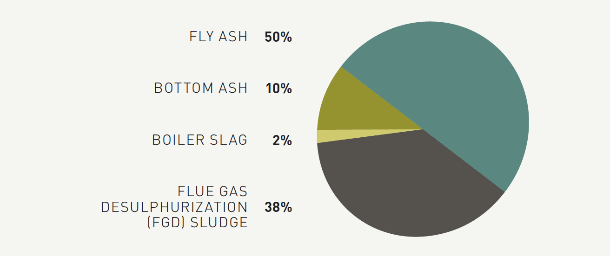Source: Earthjustice Ash in Lungs report (2014)
Two factors that dramatically increase the risk from disposal units are the use of wet surface impoundments instead of dry landfills, and whether disposal units have composite liners to prevent leaking and leaching. Surface impoundments (the wet ash ponds) consistently show higher risks than landfills.

Pathways to Contamination and Exposure
Coal ash is also often dumped into large earthen dams that can and do break, casting disastrous spills and leaks. One of the most notorious of these spills was when the Tennessee Valley Authority (TVA) massive coal ash pond dam burst in 2008. This dam burst spilled over 1 billion of toxic sludge across 300 acres. 40 homes nearby were destroyed and nearby rivers were polluted. The estimated cleanup and economic costs of this spill are estimated at $3 billion. This spill was not the outlier- there are over 200 documented instances of coal ash contaminating surrounding waters across the country.

Although the bursting of “wet” coal ash dams is more widely known, “dry” coal ash landfills present a grave threat as well. Powdery coal ash can blow off of exposed piles, fills and pits, and contaminate the air we breathe. Rain or snowmelt can still contact these dry landfills, and seep toxic chemicals into groundwater, and often flow into the nearest waterbody. In the 2019 national coal ash report from Earthjustice, recent groundwater monitoring data from regulated landfills reveals that 76% of CCR landfills have contaminated groundwater above federal health standards versus 92% of ponds. The data in the table below show that dry landfills still present a severe threat to groundwater pollution.

Table: Unsafe levels of coal ash pollutants at landfills and impoundments (percent of landfills or impoundments showing unsafe levels of each pollutant)
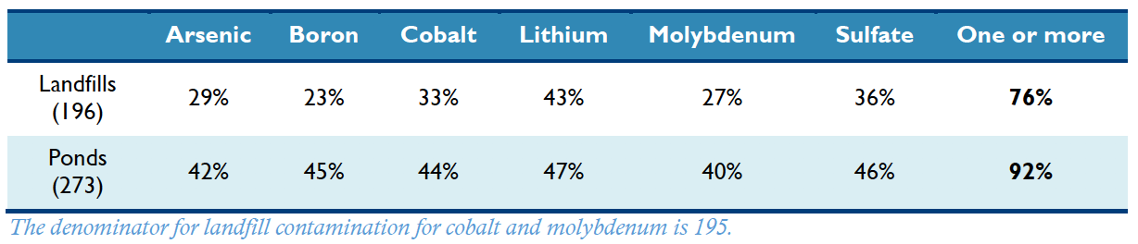

In a comprehensive national study that used 2018 data done by Earthjustice, The Environmental Integrity Project (EIP), Sierra Club and other partners, it was found that 91% of the 265 coal plants with groundwater monitoring data are contaminating groundwater with toxic substances that exceed safe levels. It was also found that 52% of coal plants have unsafe levels of arsenic (known to cause multiple types of cancer), and 60% of coal plants have unsafe levels of lithium, a chemical associated with multiple health risks.

This toxic residue of coal burning in power plants contains a hazardous mix of toxic pollutants including arsenic, boron, cadmium, chromium, lead, radium, selenium and more. Some power plants may dispose of coal ash in surface impoundments or in landfills. Others may discharge it into a nearby waterway under the plant's water discharge permit.

Limitations in Monitoring and Data
This report does not focus on the regulatory and/or monitoring framework for measuring groundwater, but it is pertinent to mention that there is likely to be groundwater and drinking water contamination that exists but has not yet been reported or made public.

The primary law that regulates coal ash is the Coal Combustion Residuals (CCR) Rule. Under this rule, beginning in 2018 coal-fired electric utilities had to follow transparency requirements and publicly report groundwater monitoring data for the first time ever. Two years later we are just viewing meaningful aggregations of this data. There is a loophole to the 2015 rule- whereby the “legacy” coal ash ponds located at retired power plants that closed before the effective date of the Rule (October 2015).

Earthjustice and EIP have mapped this data in a very user-friendly coal contamination map with the corresponding data. According to the industry’s own data, 95% of the coal ash ponds in the United States are unlined. Almost all of the plants are contaminating groundwater with toxins above levels that the EPA deems safe for drinking.

It is worth noting that the CCR Rule pertains to on-site groundwater, but this often leaves out drinking water sources in surrounding areas, which the utilities are not mandated to monitor according to this law. Neither power companies nor state regulators test private drinking water wells. Determining the drinking water quality in communities that live near coal plants is much more challenging and the data is often difficult to compare across regions. Even with the CCR rule in place, it is possible for contamination to go undetected in private wells for years, since most coal ash pollutants do not have obvious smell or color indicators.

Health Effects of Coal Ash
Exposure to the toxic chemicals found in coal ash present a serious threat to public health that could lead to severe injury and even death in some cases. People become exposed to coal ash through a variety of means. It is possible to breathe in fugitive dust that contains airborne coal ash that contains a multitude of toxic contaminants. This can come from an uncovered dump site, the back of an open truck, or in local rivers, lakes, streams or nearby forests.

Coal ash can be coarse particulate matter (PM10) as well as fine particulate matter (PM2.5). When coal ash is inhaled, the smallest particles are inhaled into the deepest parts of the lungs where they trigger inflammation and immunological reactions. From here, some particles can circulate systemically and reach further away organs where they can lead to heart or lung disease. Other particles may enter the nose directly and enter the brain directly. Small particles, especially those less than 2.5 micrometers in their aerodynamic diameter (PM2.5)
The EPA has designated particles less than 2.5 micrometers in their aerodynamic diameter (PM2.5) among the six criteria pollutants under the Clean Air Act, which requires a national air quality standard for certain pollutants that cause negative health impacts.

The EPA has found that if you live near an unlined wet ash pond (surface impoundment) and you get your drinking water from a well, you may have as much as a 1 in 50 chance of getting cancer from drinking arsenic-contaminated water.

Health Effects Overview
There are multiple coal ash pollutants that lead to a variety of health impacts that we know about. Below is information about specific contaminants and how their various negative health effects:
- Arsenic. If arsenic is ingested, it leads to nervous system damage, cardiovascular issues, and urinary tract cancers. If arsenic is inhaled, it can lead to lung cancer, and if it is absorbed into the body it can lead to skin cancer.
- Mercury. Mercury poses a specific risk to children, infants and fetuses. Mercury exposure can cause nervous system damage, developmental defects such as reduced IQ and mental retardation.
- Lead. There is no safe level of lead exposure, particularly for children. Lead exposure can lead to brain swelling, kidney disease, cardiovascular problems, nervous system damage and even death.
- Chromium. If chromium is ingested, it can lead to stomach ulcers, intestinal ulcers, stomach cancer and anemia. If chromium is frequently inhaled, exposure can lead to asthma, wheezing, and lung cancer.

Other known coal ash contaminants include chromium (including the highly toxic and carcinogenic chromium VI), uranium , selenium, molybdenum, antimony, nickel, boron, cadmium, thallium, cobalt, copper, manganese, strontium, thorium, vanadium, and others. These toxins can cause a number of health effects in humans, including neurological damage, cancer, reproductive failure, heart disease, stroke, cognitive deficits, lung disease, gastrointestinal illness. They can also lead to lasting brain damage on children, birth defects, and impaired bone growth in children. The table below provides a summary of the main coal combustion waste pollutants and the corresponding human health effects.

Human Health Effects of Some Coal Combustion Waste Pollutants
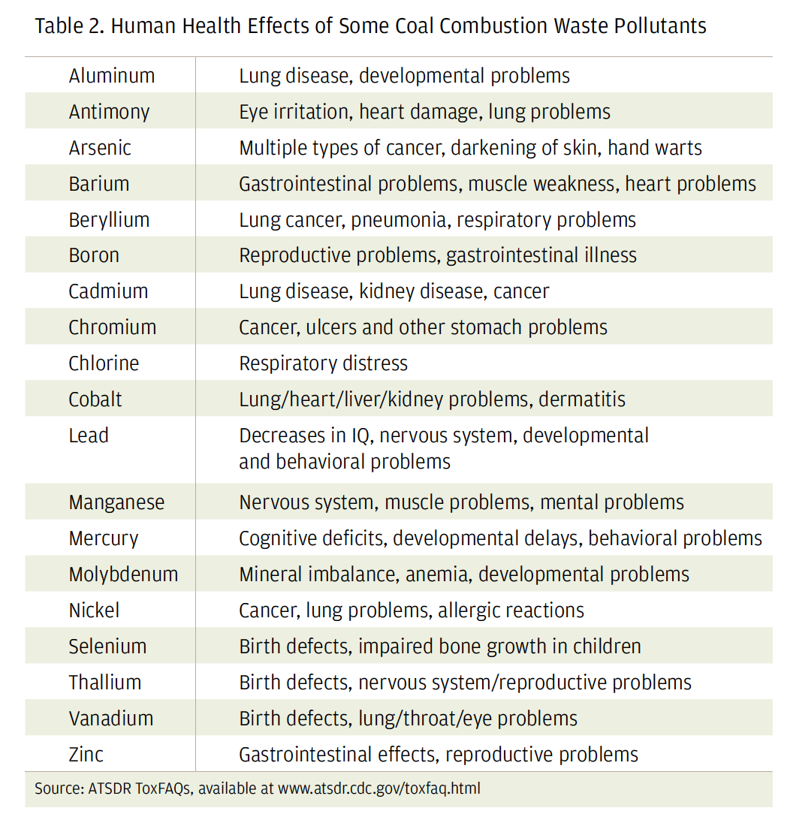
Source: ATSDR ToxFAQs

The severity of exposure depends on the particulate concentration. Higher particulate concentrations are associated with higher mortality rates. Studies have linked coal-derived particulates, including those from fly ash, to the four leading causes of death in the US: heart disease, cancer, respiratory diseases and stroke. There is also preliminary data that indicates Alzheimer’s disease and Type II diabetes mellitus may be added to known health effects.

Is it likely that employees at power plants are exposed to and inhale substantial concentrations of fly ash when they are not wearing respirators or other protective equipment. The Electric Power Research Institute found that silica exposure in U.S. coal-fired power plants often exceeded the National Institute for Occupational Safety and Health (NIOSH) health standards in areas where fly ash was handled, especially during activities that involve the maintenance of air pollution devices.

Contaminants in Focus

Silica
When coal is burned, it creates fly ash which contains significant amounts of silica both in crystalline and amorphous form. Respirable crystalline silica in coal ash can lodge in the lungs and cause silicosis, or scarring of the lung tissue. This can lead to a disabling and sometimes fatal lung disease. After many years of mild overexposure, chronic silicosis can occur. It is common for this damage to first go undetected, but chronic exposure can lead to irreversible lung damage. Fever, shortness of breath and loss of appetite and cyanosis (blue skin) are all common symptoms. The International Agency for Research on Cancer (IARC) has determined that silica causes lung cancer in humans, and the National Toxicology Program (NTP) and National Institute for Occupational Safety (NIOSH) have also classified silica as a human carcinogen.

Excessive Radioactivity
Fugitive coal ash dust also contains radioactive metals. The levels of radioactive metals attached to carbon varies, but all coals have at least come level of naturally occurring radioactive materials. These include uranium thorium, potassium, and their radioactive decay products including radium. When coal is burned, the radionuclides are concentrated roughly three to ten times the levels that can be found in the initial coal seams. When the carbon is burned off, the radioactive metals stay with the coal ash. If this coal ash dust is inhaled, radioactive materials will be transported into a person’s lungs. The radioactive metals will then undergo radioactive decay and the resulting water-soluble radium can be transported to a person’s bones where it will replace calcium. It will also decay further into radon gas, which is the second leading cause of lung cancer (after tobacco smoke) in the US. Since radon gas is heavier than air, it is often found in low-lying areas unless the wind carries it away as it is mixed with air. This dust can contaminate surface water supplies and does not need to be inhaled.

Hydrogen Sulfide
Coal ash contains high levels of sulfur, and hydrogen sulfide is then often released at coal ash landfills and impoundments. Hydrogen sulfide is mostly released as a gas and spreads in the air. It is a flammable, colorless gas with the smell of rotten eggs. Workers at coal plants as well as community members that live near coal plants or dumps are often exposed to hydrogen sulfide by breathing in the air. Nausea, irritation to the eyes, nose or throat may result from low concentrations of hydrogen sulfide. Communities near coal plants or dumps may be exposed to hydrogen sulfide by breathing in contaminated air. Asthmatics may also experience difficulty breathing. Since the hydrogen sulfide is heavier than air, children are sometimes exposed to more hydrogen sulfide since they are shorter.

Environmental Effects of Coal Ash
For decades, coal ash has polluted fragile ecosystems pollutants traveling through rivers, streams, lakes and reservoirs. Coal ash toxins that bioaccumulate such as arsenic, cadmium, chromium, lead, mercury and selenium have led to fish kills, deformities in fish and amphibians. This can lead to human health problems too for those who then eat these fish.

Three main toxins that are commonly found in coal ash are arsenic, methyl mercury and selenium. These present an increased danger to humans and other animals through ingestion. One study that reviews documented environmental damage since 1967 showed that coal ash has injured fish, birds, amphibians and wildlife at various locations across the United States. It is difficult for water quality data, surface water, and fish tissue data to be widely available at multiple locations, which limits these findings.

Earthjustice identified 28 sites of contaminated water bodies as documented by the EPA, which is not comprehensive due to data limitations. Within these sites, one expert estimated that the combined direct and indirect cost of poisoned fish and wildlife at 21 of these sites exceeds $2.3 billion.

In the wake of the Tennessee Valley Authority (TVA) coal ash spill in Kingston, TN, rigorous scientific studies have been done to assess the extent of the damage. One 18-month long investigation revealed that leachable coal ash contaminants (LCACs), particularly arsenic, selenium, boron, strontium, and barium, had different effects on the quality of impacted environments. Elevated LCACs were found in surface water and the high concentration of arsenic (up to 2000 μg/L) was found to be associated with some degree of anoxic conditions.

One comprehensive study that focuses on aspects of CCR that have the potential to negatively influence aquatic organisms and the health of aquatic ecosystems found that a large number of metals and trace elements are present in CCR, some of which are rapidly accumulated to high concentrations by aquatic organisms. In some vertebrates and invertebrates, CCR exposure led to numerous behavioral, and physiological (reproductive, energetic, and endocrinological) effects. Fish kills and local extinction of some fish species have been associated with CCR release, as have indirect effects on survival and growth of aquatic animals mediated by changes in resource abundance or quality.

One paper that assesses damage cost of the Dan river coal ash spill in North Carolina estimates the combined cost of ecological damage, recreational impacts, effects on human health and consumptive use, and esthetic value losses to be $295,485,000.

Contaminant in Focus: Selenium
Selenium presents a particular danger since low levels of this pollutant are toxic to aquatic life. Selenium bioaccumulates in food chains and passes this toxin from parents to offspring in eggs, where it leads to a variety of skeletal deformities and other abnormalities in the developing embryos. Bioaccumulation occurs when an organism absorbs a substance at a rate faster than that at which the substance is lost or eliminated by catabolism and excretion. When this happens with a pollutant, this can lead to massive reproductive failure and local extinction of species.

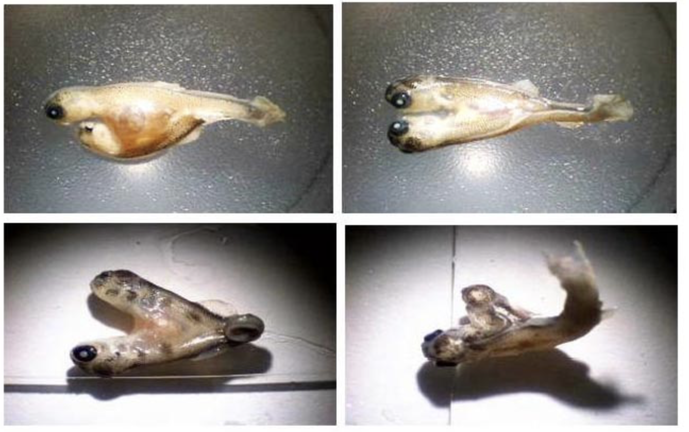
A study commissioned by the J.R. Simplot Company on selenium contamination in creeks in southeast Idaho includes photos of deformed Yellowstone cutthroat trout (top) and brown trout (bottom). Selenium is one of the most common coal ash contaminants found near coal ash dumps — frequently at levels higher than those measured in the Idaho stream that spawned the two-headed fish.

The most studied case of coal ash damage occurred at Belews Lake in North Carolina in the 1970s when coal ash-contaminated water from an ash pond at Duke Energy’s Belews Creek Steam Station caused long-term catastrophic toxicity. Selenium killed 19 of the 20 fish species in 3800-acre Belews Lake. Damage to fish and birds lasted in the lake for decades.

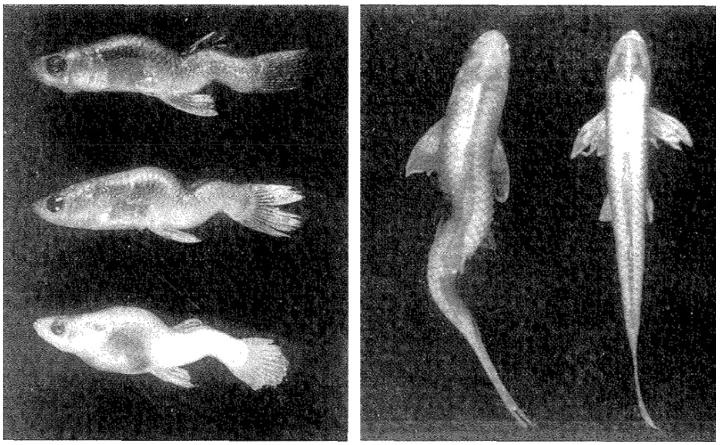
One of the most visible effects of selenium in Belews Lake was spinal deformities, as shown in mosquitofish (left) and a red shiner (right). Individual on the far right is normal.

Known Contamination on Navajo Nation
The arid climate of the Four Corners region creates a particular challenge since the coal ash dries rapidly and is largely uncontained.

Earthjustice and the EIP’s comprehensive coal ash contamination map aggregates industry disclosures posted on individual owner/operator websites as it relates to the 2015 CCR Rule. This data describes the status of groundwater monitoring and whether the operator has found groundwater contamination from coal ash.

Under this analysis, different coal plant units are given a hazard rating that ranges from low to high, as well as N/A and incised. The hazard rating definitions are given as follows:
- Low: Failure or mis-operation would be unlikely to cause loss of life or significant economic or environmental losses, with losses principally limited to the owner’s property.
- Significant: a failure of mis-operation of this dam would probably not cause any deaths, but it would cause economic loss, environmental damage, and a disruption of lifeline facilities.
- High: Failure or mis-operation of these dams will probably cause loss of human life.
- Incised:These impoundments do not have dams because they are entirely below ground level. Therefore they have no dam ratings, although underground failures can and do occur.
- N/A: This requirement only applies to surface impoundments, not landfills.

Plant-specific data regarding contamination above levels that the EPA deems safe to drink is from the aggregated CCR compliance data unless otherwise noted.

Four Corners Power Plant
Four Corners Power Plant (FCPP) is a 1,540 megawatt coal-fired power plant, and one of the biggest coal-fired power plants in the West. There are several coal ash ponds and a landfill that rise over one hundred feet above the desert. Together these create enormous pollution including clouds of toxic dust. FCPP is open and set to close in 2031. It has a closure plan which describes how this will happen. Independent analysis shows that about 50 million tons of coal ash have been disposed of at the FCPP property. In addition, there is also 33.5 million tons of CCRs that have been dumped off-site at the abandoned pits at the Navajo Mine, bringing the total of CCRs generated at FCPP closer to 84 million tons. The most recent 2019 CCR compliance report contains detailed groundwater for each unit. Coal ash waste has been dumped in a combination of ways- in unlined wet impoundments, a “dry” landfill, and dumped offsite in abandoned mine pits of the Navajo Mine.

Navajo Mine supplies coal to FCPP and operations began in 1963. From 2001- 2012 BHP Billiton owned Navajo Mine and in 2013 the Navajo Nation created Navajo Transitional Energy Company (NTEC) to purchase the Navajo Mine. In 2015, NTEC announced that Bisti Fuels, a subsidiary of North American Coal Company, would begin operating the mine on their behalf, which started in 2017.

For more than thirty years fly ash, bottom ash and scrubber sludge from the Four Corners Power Plant was placed in unlined impoundments and backfilled into the Navajo Mine, which has supplied coal to the plant since 1968. APS has already stored 50 to 55 million tons of coal ash in unlined pits near the San Juan River and more recently are believed to be storing it in stockpiles. In 2008, the New Mexico Office of the State Engineer commented that the coal ash dams at the FCPP should be classified as High Hazard Potential dams. There have been concerns in violation of the open dumping prohibition of the Resource Conservation and Recovery Act (RCRA). Until 2008, BHP was dumping CCW back into the Navajo Mine. The DEIS fails to submit adequate scientific information on the effects of CCW disposal practices at FCPP.

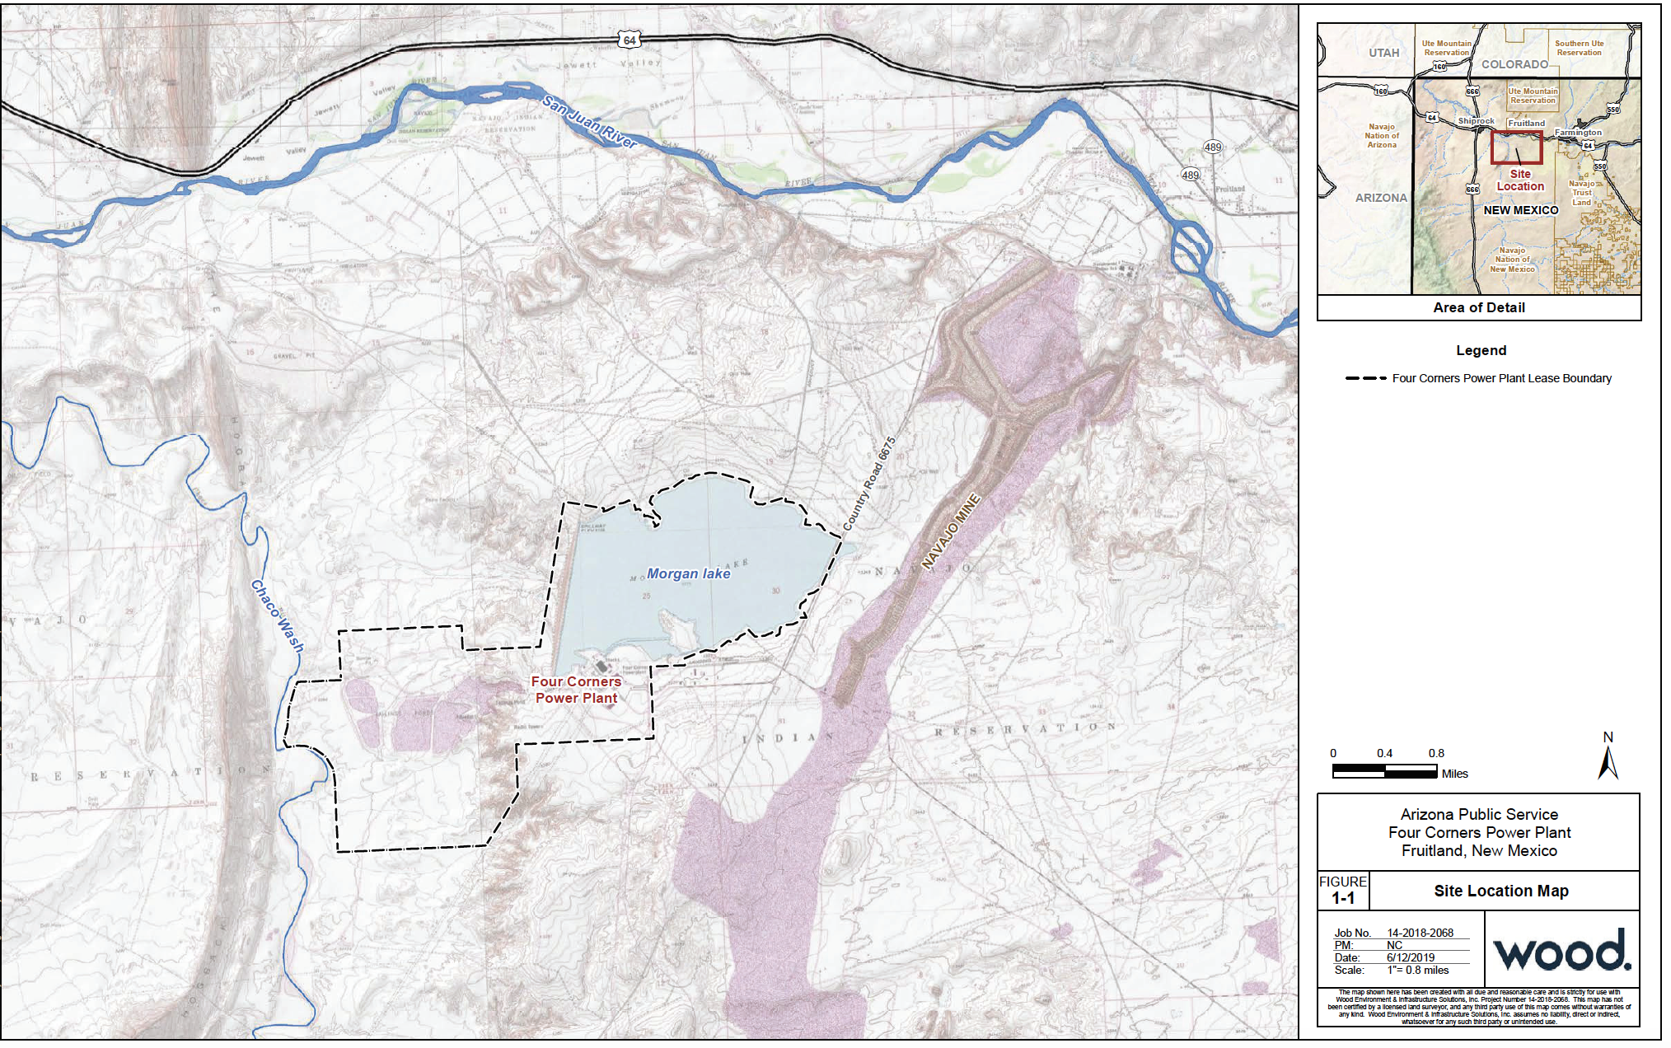
Source: CCR Groundwater Monitoring System Compliance report

One of the main concerns of RCRA is that “open dumping is particularly harmful to health, contaminates drinking water from underground and surface supplies, and pollutes the air and land.” 42 U.S.C. § 6901(b)(4). In comments on the FCPP DEIS, concerns were raised that coal combustion waste (CCW) practices of discharging coal ash onto land at the FCPP and Navajo mine constitute illegal open dumping under RCRA. It was noted that the DEIS is deficient for failing to analyze whether activities at the FCPP and Navajo mine have violated this federal law and the remedial measures that must be immediately employed to achieve compliance with the Act. The comments noted that the DEIS also fails to analyze APS’s exposure to civil penalties under RCRA for its 30 years of illegal CCW disposal practices. Pollutants found in the groundwater pollution at the FCPP contain metals, selenium, and other compounds that pose a threat to aquatic life, birds, mammals, and plant-life.

According to APS’ own analysis, up to 20 feet of CCRs is present beneath the combined waste treatment pond, and that “the area where the CWTP is located was used for other purposes.” There is evidence that contaminated CCR leachate and slurry water were (1) actively discharged to surface water drainages and the Chaco River for at least 16 years, and (2) infiltrating the subsurface through the unlined base of the ash ponds for many decades.

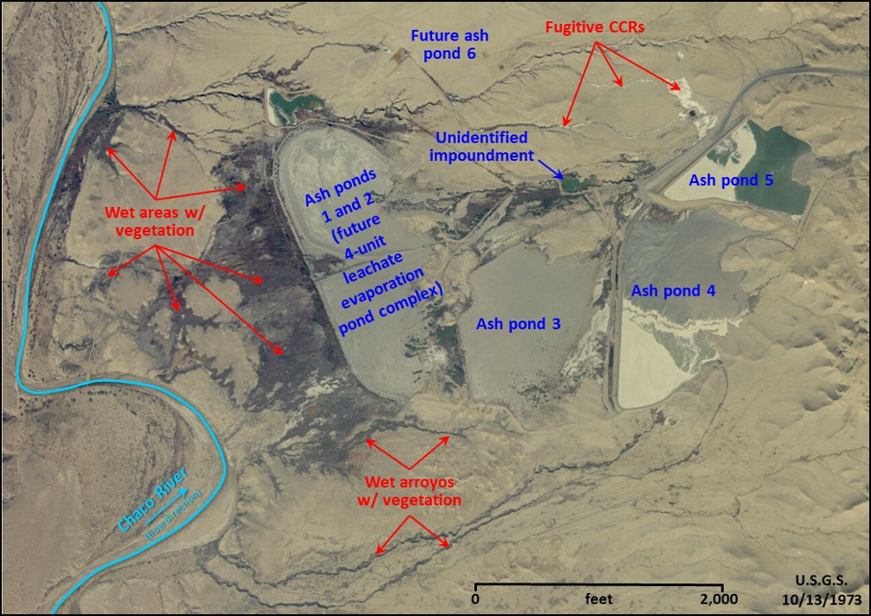
Annotated portion of a United States Geological Survey aerial photograph showing CCR disposal units, fugitive CCRs, and contaminated water supporting vegetation at FCPP on 10/13/1973

Slurry water standing in pond 6 “was decanted…(and returned) back to the power plant for reuse.” The CCR leachate and discharge impacts on the Chaco River had concerned the State of New Mexico enough that discussions about corrective actions were initiated.

In an independent analysis of APS’ groundwater, it was noted that the “background” monitoring wells are generally located improperly, and that the monitoring has been skewed to downplay the true levels of contamination, and that the size of contamination plumes is likely much larger than APS claims. APS has undertaken expensive efforts, such as installing a deeply-buried 1.4 mile long trench system between the disposed CCRs and the Chaco River in an attempt to capture the groundwater contamination migrating toward the Chaco river from the unlined coal ash impoundments and the active CCR units. This suggests that the network of pumping wells had not remediated the risk or impacts of the Chaco River. For this, APS claims that their trench is “effectively intercepting and removing groundwater”, but they do not provide any volume records or analytical data for the recovered water. 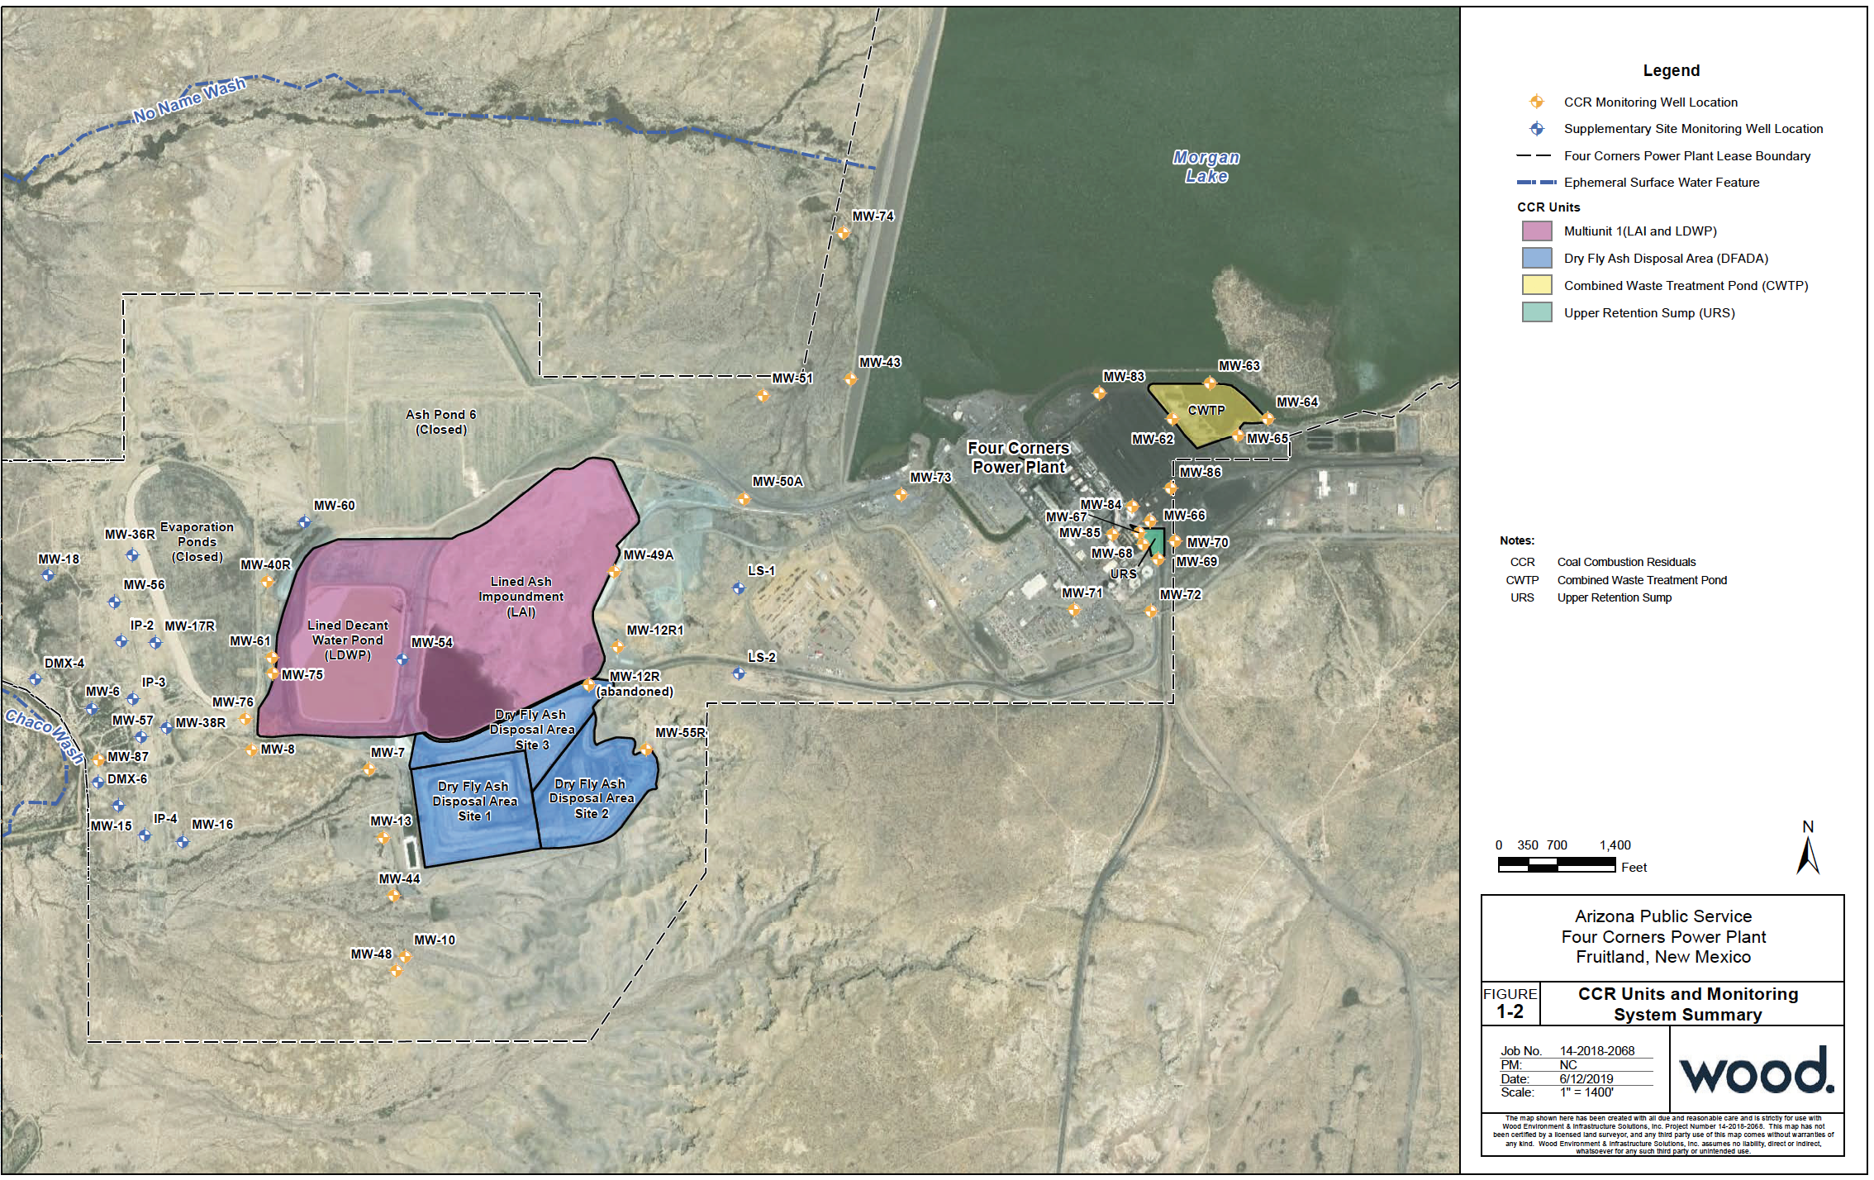
Source: CCR Groundwater Monitoring System Compliance report

There are five CCR units within the FCPP. The Lined Ash Impoundment has a significant hazard rating with the following levels of contaminants above drinking water standards: Arsenic (x1), Boron (x42), Chromium (x1), Cobalt (x45), Fluoride (x5), Lead (x2), Lithium (x20), Molybdenum (x4), Radium (x5), Selenium (x2), Sulfate (x21). In the Lined Ash Impoundment, there is toxic metal contamination from cobalt and molybdenum. This unit is unlined and contains 8.6 million tons of coal ash. It stands 107 feet high and 6600 feet long, and will be closed in place. It is subject to groundwater cleanup requirements due to high levels of cobalt and molybdenum.

The Lined Decant Water Pond also has a significant hazard rating and the following levels of contaminants above drinking water standards: Arsenic (x1), Boron (x42), Chromium (x1), Cobalt (x45), Fluoride (x5), Lead (x2), Lithium (x20), Molybdenum (x4), Radium (x5), Selenium (x2), Sulfate (x21). In the Lined Decant Water Pond, there is also toxic metal contamination from cobalt and molybdenum. It is unlined, stands 90 feet high and will be closed in place. It is subject to groundwater cleanup requirements due to high levels of cobalt and molybdenum.

The Upper Retention Sump has an incised hazard rating with the following levels of contaminants above drinking water standards: Arsenic (x1), Boron (x42), Chromium (x1), Cobalt (x45), Fluoride (x5), Lead (x2), Lithium (x20), Molybdenum (x4), Radium (x5), Selenium (x2), Sulfate (x21). The Upper Retention Sump has a notice of intent to close with closure by removal. This unit is unlined and violates aquifer restriction (the bottom of the pond sits within 5 feet of groundwater). This surface impoundment is subject to groundwater cleanup due to excess levels of fluoride.

The Combined Waste Treatment Pond has a low hazard rating with the following levels of contaminants above drinking water standards: Arsenic (x1), Boron (x42), Chromium (x1), Cobalt (x45), Fluoride (x5), Lead (x2), Lithium (x20), Molybdenum (x4), Radium (x5), Selenium (x2), Sulfate (x21). This unit stands 32 feet high and contains 221,026 tons of coal ash. This surface impoundment will be closed by removing coal ash and groundwater monitoring in process. This unit is unlined and violates the aquifer restriction.

The following table summarizes the contaminants above EPA drinking standards across the different units at FCPP.

Table: FCPP contaminants above EPA drinking standards
 | Arsenic | Boron | Chromium | Fluoride | Lead | Molybdenum | Radium | Selenium | Sulfate | Cobalt | Lithium
Lined Ash Impoundment | x1 | x42 | x1 | x5 | x2 | x4 | x5 | x2 | x21 | n/a | n/a
Lined Decant Water Pond | x1 | x42 | x1 | x5 | x2 | x4 | x5 | x2 | x21 | x45 | x20
Upper Retention Sump | x1 | x42 | x1 | x45 | x2 | x4 | x5 | x2 | x21 | x45 | n/a
The Combined Waste Treatment Pond | x1 | x42 | x1 | x5 | x2 | x4 | x5 | x2 | x21 | n/a | n/a

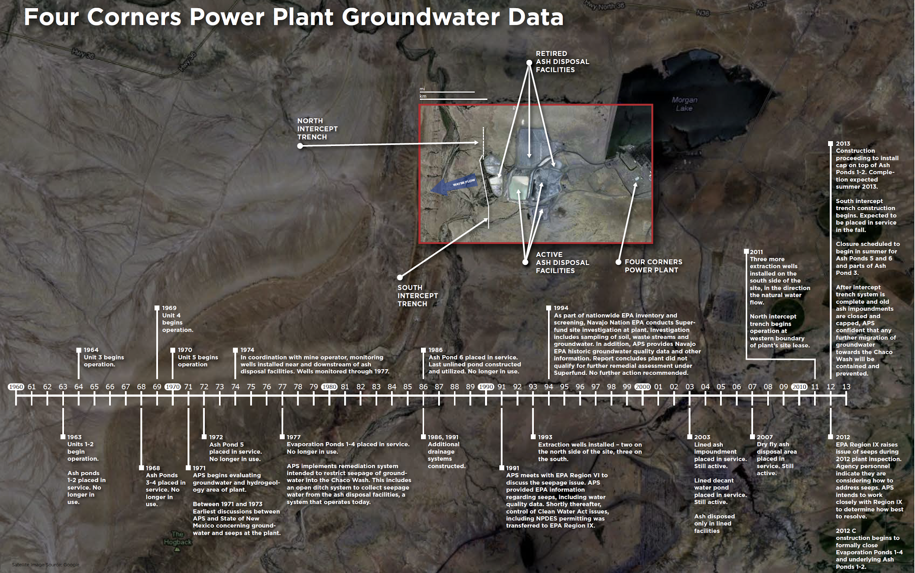Timeline of Four corners Power Plant Groundwater Data

FCPP is a top coal plant emitter of Nitrogen oxides in the U.S. – with an estimated 44,649 tons of emissions per year. FCPP has a fifty year legacy where there has been accumulation of toxic contaminants, including the deposition of mercury across the region’s waterways.

The Dry Fly Ash Disposal Area does not have a CCR hazard rating, since disposal requirements only apply to surface impoundments, not landfills. This landfill is unlined and violates the aquifer restriction.

All CCRs disposed prior to the 2015 CCR Rule in “closed” on-site wet impoundments have been abandoned in place, with only minimal engineering controls installed to limit the generation and escape of groundwater contamination from those units. APS has repeatedly stated their intent to close in place some active CCR units, beginning as soon as fall 2020.

San Juan Generating Station
San Juan Generating Station is a coal-fired electric power plant sourced by the San Juan Mine. In 2017, Units 2 and 3 (369 and 555 MW, completed in 1976 and 1979, respectively) were retired. Units 1 and 4 (also 369 and 555 MW, completed in 1973 and 1982, respectively) are scheduled to shut down in 2022, but there is still a possibility that new owners may purchase it before then. The plant is New Mexico’s single largest polluter and the Public Service Company of New Mexico (PNM) is the largest owner.

Coal ash generated at the San Juan Generating Station (SJGS) is returned to the adjacent mines for use in reclamation, so this station does not have or utilize ash impoundments or landfills, and therefore there is no CCR compliance data.

In a national analysis from Earthjustice that identifies known drinking water contamination (different from the mandatory CCR groundwater reporting data), contaminants were found in the drinking water at SJGS. In Earthjustice’s Waste Deep report, arsenic, boron, lead, sulfates and selenium were found in an unlined pond.
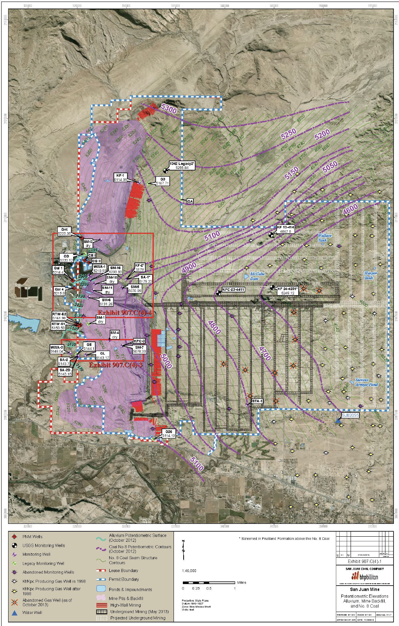
Map San Juan Mine Groundwater Monitoring Wells

Since the late 1980s, forty million tons of coal combustion waste have been dumped in the San Juan Mine. This has poisoned the shallow groundwater and surface water in the Shumway Arroyo. Levels of lead, selenium, arsenic, cadmium, and boron have risen above drinking water standards in the shallow gravel aquifer below the arroyo.
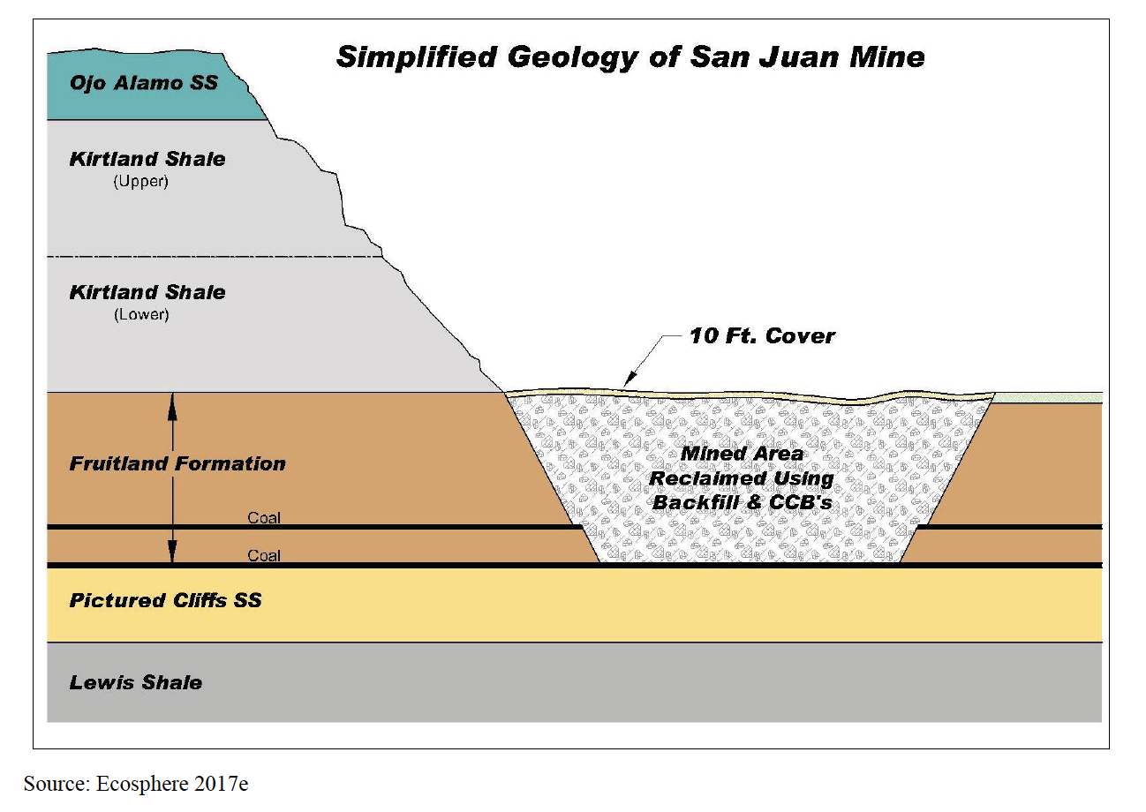
Simplified Geology of the San Juan Mine

At the boundary of the San Juan mine, sulfates in the aquifer have reached 55,000 milligrams per liter (mg/L), which is 220 times the secondary drinking water standard. Total dissolved solids can be an indicator of all pollution in water and were found exceeding 80,000 mg/L, which is 160 times the federal standard. The Shumway Arroyo, which was previously a drinking water source for residents and their livestock, has been poisoned by coal ash. This water from the Shumway Arroyo flows into the San Juan river, which is a drinking source for thousands.

Although PNM lined its ash disposal site ponds in response to 1984 EPA changes, the dumping of coal combustion waste in unlined sites accelerated afterwards. PNM required San Juan Mine (its main coal supplier) to backhaul more of PNM’s coal ash to the mine’s pits. Since 1987, The San Juan Mine has been filling more than 20 pits with CCW, ranging from a few acres to hundreds of acres in size. Large unlined pits, nearly 200 feet deep and 300 feet wide are now filled with concentrated, battleship-sized tonnages of caustic fly ash and scrubber sludge. Since the pits are located above the arroyo, CCW continues to poison the groundwater.

Table: Summary of No. 8 Coal Seam Groundwater Quality from 2009-2017
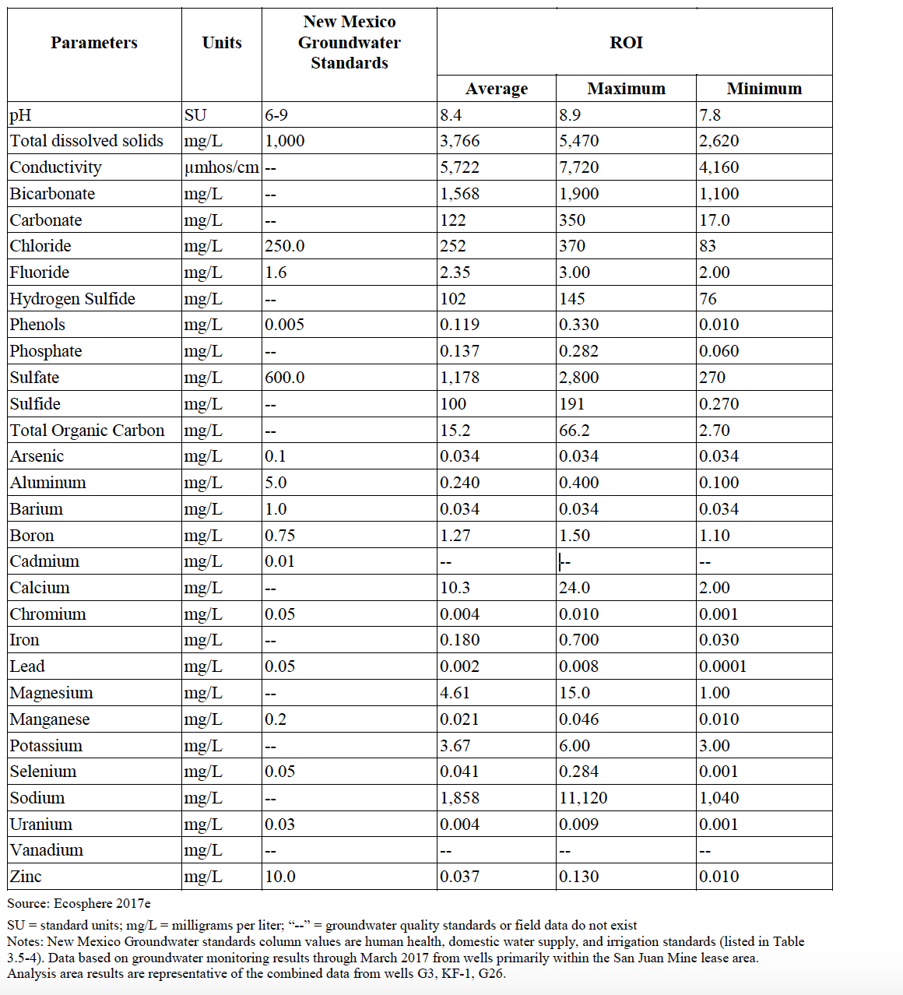

The Office of Surface Mining and Reclamation Enforcement (OSMRE) SGJS Lease Extension Final EIS contains historical emissions data for the plant. The operations of the SJGS between 2008-2017 is characterized by all four boiler generating units operating on varying schedules at different capacities for each year. The four boiler stacks are the dominant emission sources. The document notes that fugitive dust emissions from haul truck travel on unpaved roads, coal pile wind erosion, and bulldozer activities are the largest sources of particulate emissions, much larger than the mechanical crushing and transport of coal. In a 2012 case, environmental group Sierra Club claimed that the San Juan Coal Company, BHP Billiton and PNM violated the requirements under the Surface Mining Control and Reclamation Act.

Table: Historical Aggregated Emissions for the Generating Station 2008-2016.
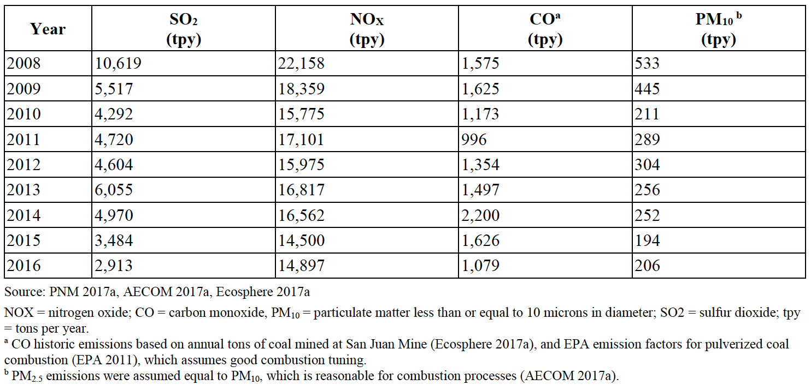
The table below summarizes the peak model-predicted impacts for the pre-2017 scenario for each pollutant and averaging period addressed by national and state ambient air standards. This scenario estimated the emissions from the San Juan Mine, including combustion of coal at the Generating Station between 2008 and 2017. Gaseous pollutants (SO2, NO2, and CO) are contributed by the San Juan Mine ventilation engines, but are primarily emitted from the elevated Generating Station stacks, and transported to more distant locations. According to the document, the highest impacts from gaseous pollutant emissions were predicted to occur to the southeast in the case of NO2 (due to the stacks and GVB engines), and in elevated unoccupied areas to the north of the facilities for CO and SO2. Particulate impacts that are driven by material handling activities at the San Juan Mine and Generating Station (TSP, PM10, and PM2.5) are generally predicted to be higher at short distances from the ground-level sources of those pollutants.

Table: Contribution of San juan Mine and Generating Station Criteria Pollutant 2008-2017 and Comparison to Air Quality Standards
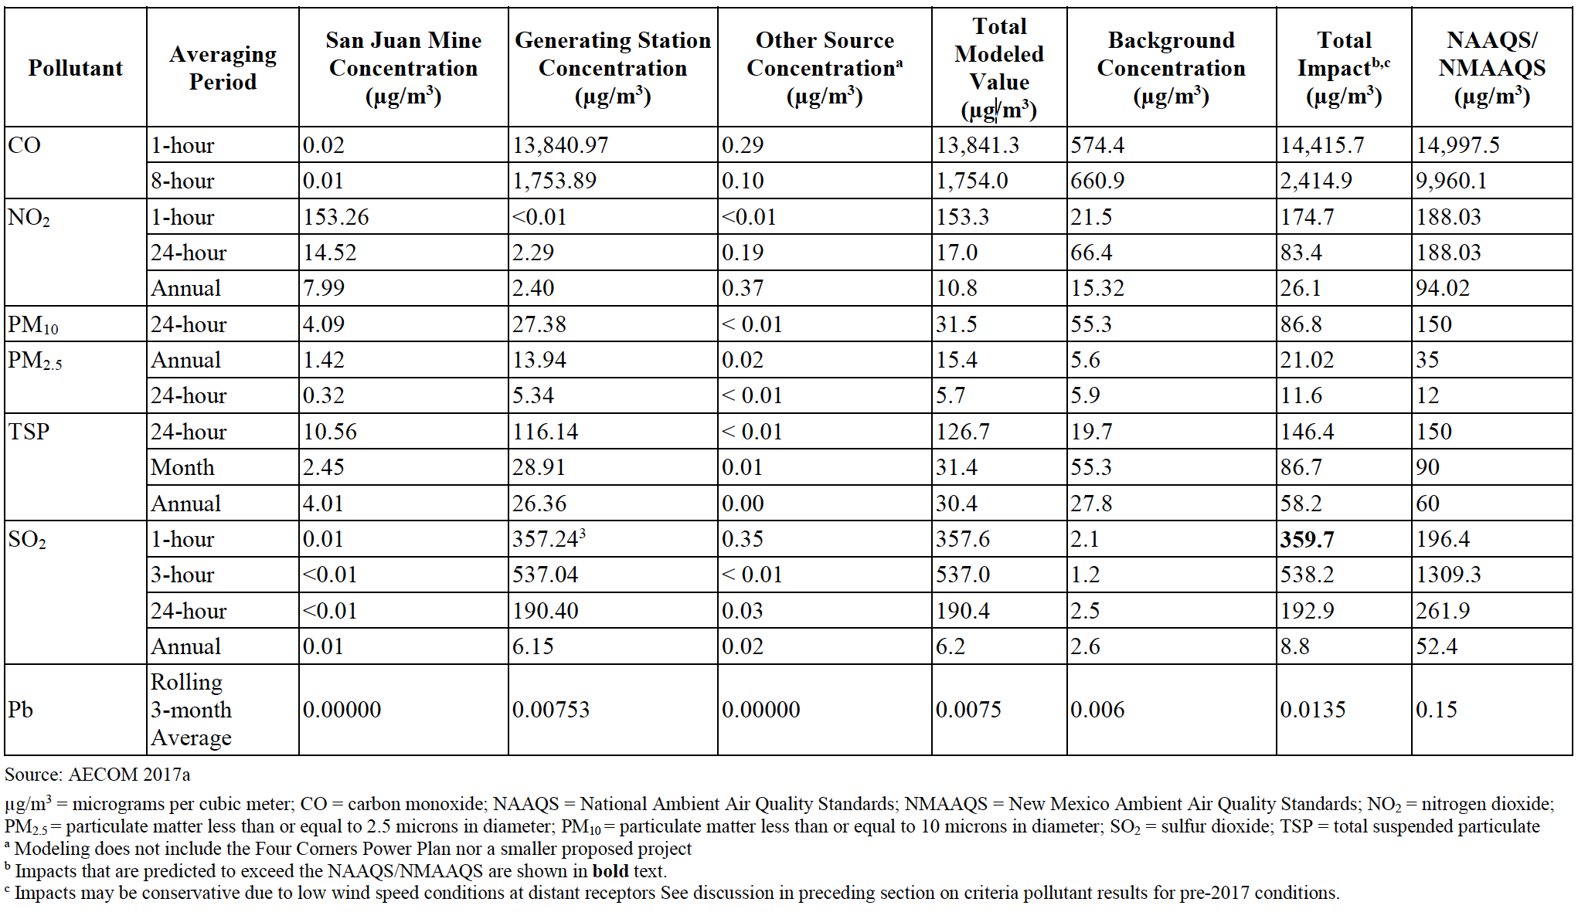

The following table shows a summary of fish and aquatic contaminants in the San Juan River.

San Juan River- Fish and Aquatic Invertebrates, Summary of Selected ERA Risk Assessment (Hazard Quotients) Results
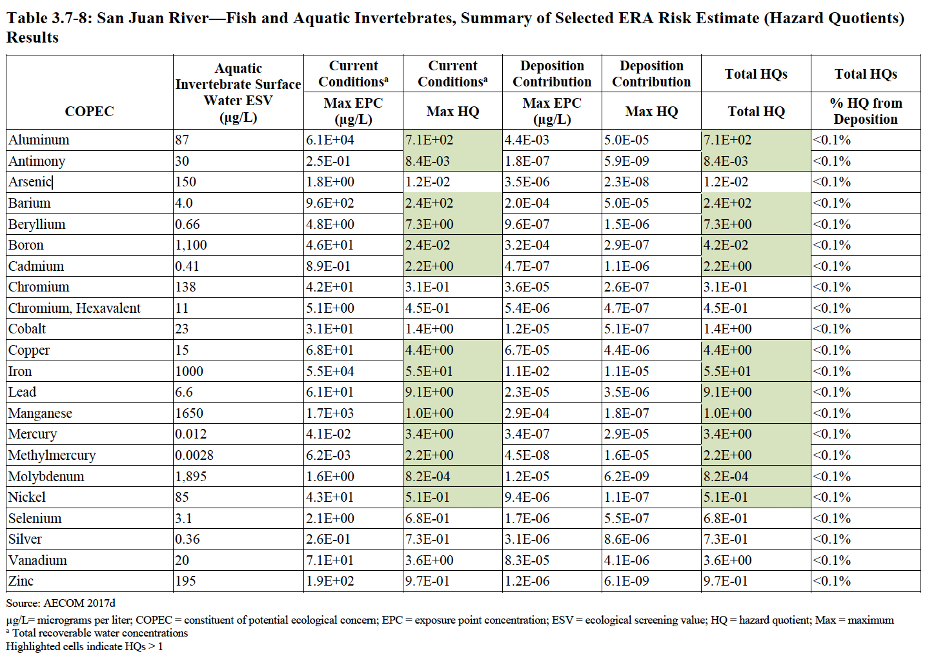
Source: 2019 San Juan Mine Deep Lease Extension Mining Plan Modification

Navajo Generating Station
Navajo Generating Station (NGS) was a 2.25-gigawatt coal-fired power plant that closed in November, 2019. NGS and the associated Kayenta Mine Complex (KMC) has one coal ash landfill for the retired plant. The KMC is the sole source of coal buried at NGS, and NGS was the sole user of KMC coal. Most of the coal ash produced by NGS was disposed of 1.5 miles east of the plant at a dedicated landfill totaling 765 acres. The landfill has a nominal capacity of 38 million cubic yards of CCR. Most of the remaining 1,021 acres (of 1,786 leased by the Navajo Nation) are occupied by the NGS power plant.

Pollution sources at the NGS plant include several landfills, lined and unlined industrial ponds, multiple industrial wastewater treatment and storage basins, some which remain potential contamination sources even though they are no longer in use. By 2014, there was reported to be approximately 18 million cubic yards already in the coal ash landfill, and the area covered by coal ash is approximately 400 acres. However, it is still not clear how much CCR is actually disposed of at the NGS landfill.
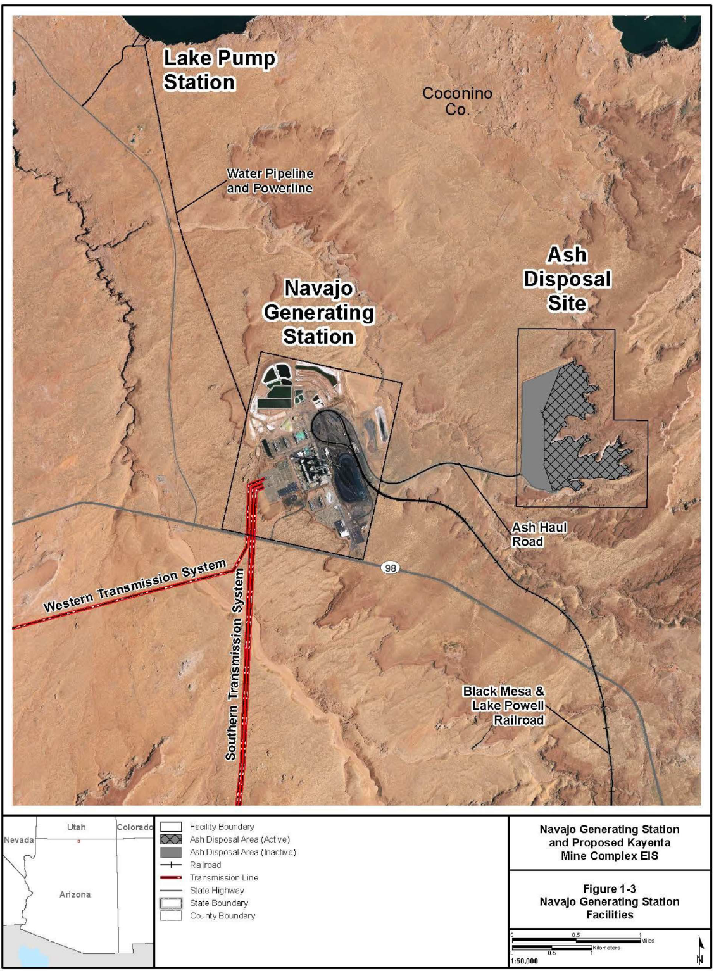
Source: 2016 Draft Environmental Impact Statement (DEIS) for NGS
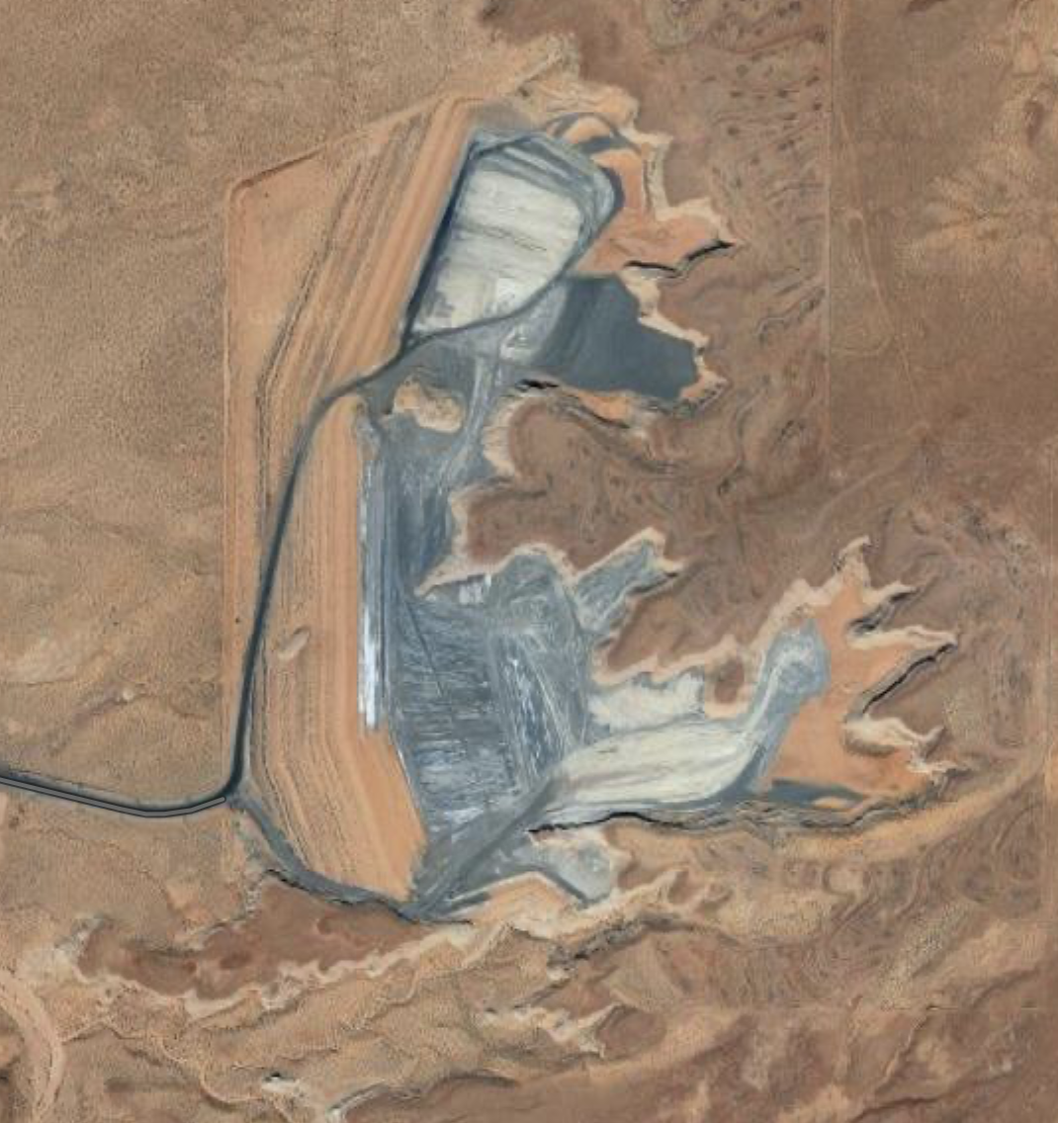
View of the Navajo Generating Station Coal-Ash Disposal Site in December 2020 (source: Google maps)

NGS does not have a hazard rating since disposal requirements only apply to surface impoundments, not landfills. Data did not show any pollutants present at unsafe levels for drinking water. This landfill contains about 20 million tons of coal ash and will be closed in place. This landfill has significant groundwater contamination and does not have aquifer requirements. In December, 2020 the three smokestacks of Navajo Generating Station came down, with remediation efforts to follow.

The NGS is located approximately 4,375 feet above mean sea level (AMSL). The surface of the coal combustion residuals previously disposed of in the CCR landfill are approximately 4,530 feet AMSL. The base of the retention dam (aka, dike or berm) holding the coal ash in place against the natural topography formed upon sandstone is approximately 1.15 miles in length and occurs at an elevation of 4,390 feet AMSL, so the retention dam is more than 140 feet high. In 2015, coal ash was being disposed of at an elevation of approximately 4,510 feet AMSL in the northern third of the ash pit. The ash-retention dam is constructed of ash covered with a veneer of soil that appears to lack stabilizing vegetation other than what has grown voluntarily.
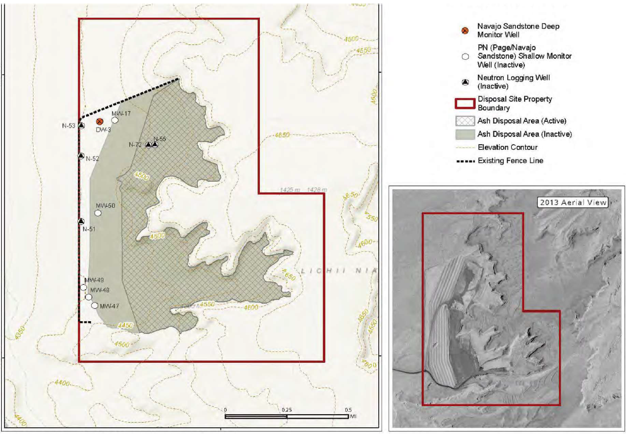
Layout of NGS Coal-Ash Disposal Site and Groundwater Monitoring Wells (source: modified from Figure 4 SRP 2016 DEIS)

The Carmel Formation that the NGS is located upon did not contain groundwater prior to the operation of the NGS plant, and now there is a “new” aquifer. The evaluation report on geologic and hydrogeologic aspects of the 2016 Draft Environmental Impact Statement (DEIS) for NGS describes that two distinct groundwater systems are at risk of contamination by NGS activities and waste disposal, including the coal ash landfill. Within the relatively thin Carmel Formation, there is a shallow zone of groundwater that is exposed or very near the land surface at the NGS plant. A major regional groundwater (aquifer) system (N Aquifer) is in the massive Navajo Sandstone located beneath the Carmel Formation. Monitoring of groundwater distribution and quality in the Carmel Formation is occurring, even though there should be no such groundwater since the NGS is a zero liquid discharge (ZLD) facility and the DEIS reports that the Carmel Foundation was “dry” prior to building the power plant. Unintentional leakage of industry-impacted water from this ZLD facility has formed a “new” aquifer in the Carmel Formation, and groundwater is now located as littles as five feet below the NGS plant.
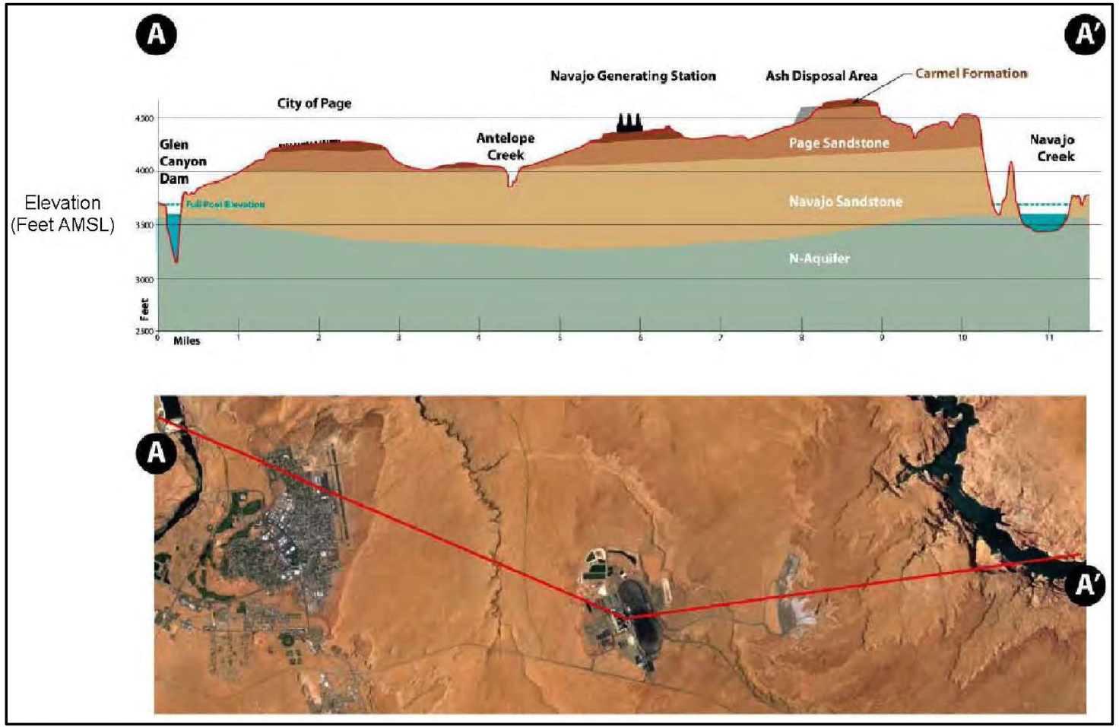
Generalized Cross-Section across the NGS

Beneath the Carmel Formation is the Navajo Sandstone, and that unit is saturated with groundwater (the “N Aquifer”) below the NGS at an average depth of 870 feet. The NGS is actively pumping wells tapping the Carmel Formation to remove contaminated groundwater that contains concentrations of heavy metals, sulfate and total dissolved solids (TDS), and some of these concentrations exceed federal water-quality standards. In one instance, water pumped from a well in October of 2015 contained the toxic heavy metal selenium at a concentration almost four times the federal water-quality standard.

There is only one active monitoring well at the coal ash landfill, deep well DW-3, which taps the N Aquifer. The DEIS shows that DW-3 is being sampled and analyzed on a semi-annual basis for the following parameters: arsenic, barium, cadmium, chromium, fluoride, lead, selenium, sulfate and total dissolved solids (TDS). It also acknowledges that groundwater distribution and quality have been impacted by historical activities at NGS (such as industry-impacted groundwater accumulation in the previously-dry Carmel Formation). The table below shows the most recent groundwater data from SRP for their wells.

Table: Summary of Analytical Results- Detection Monitoring NGS- Ash Landfill
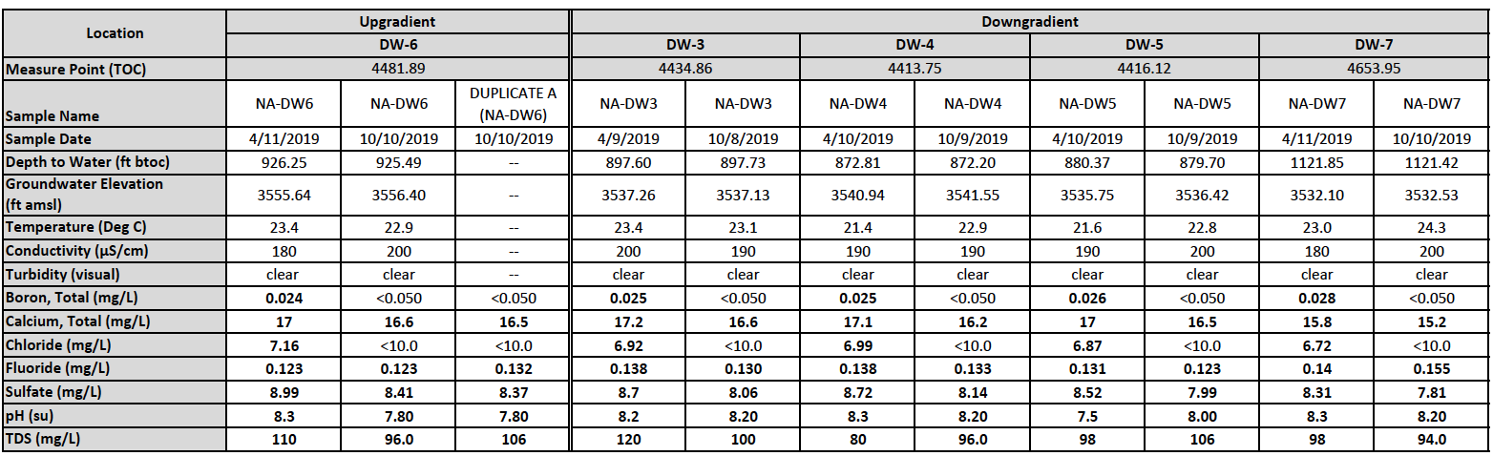
The map below shows the monitoring wells for the coal ash landfill that corresponds to the previous table. According to Ashtracker, these contamination levels are all under the federal drinking water standards.

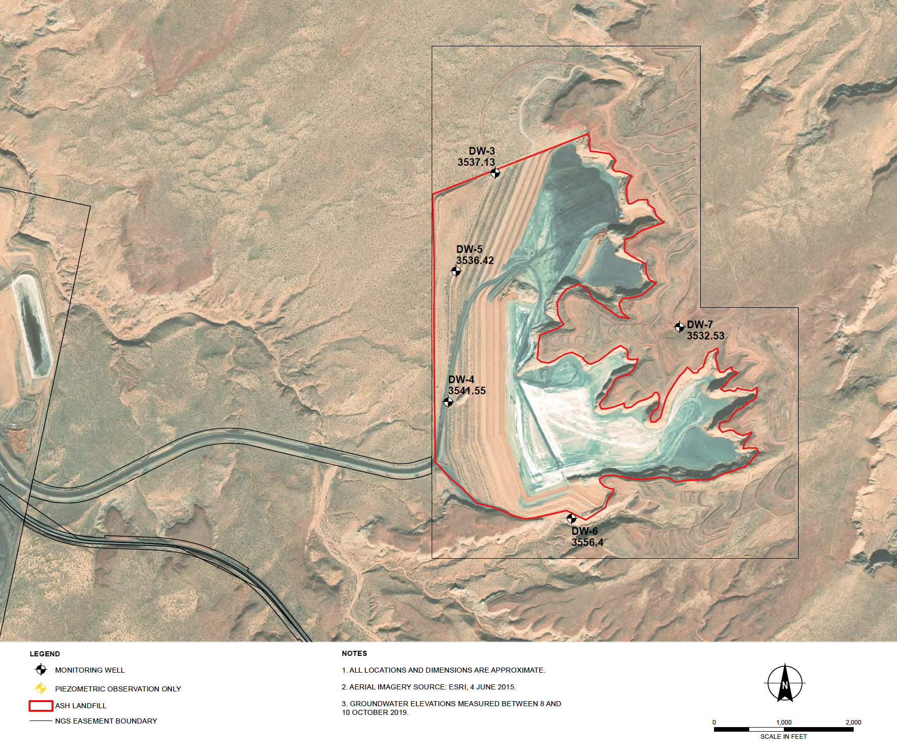
Map of NGS Landfill Monitoring wells

This means that the water could be contaminated from operation of NGS and the ash disposal landfill. It is possible that groundwater in the N Aquifer is contaminated. The full extent of the contamination in the N Aquifer may not be known because contaminants may migrate slowly or through complex migration pathways.

Cholla
Cholla power plant is a 767 MW coal plant operated by APS and Pacificorp that began operations 1962. Unit 2 was retired in 2016, Unit 4 is scheduled to retire at the end of 2020, and Units 1 and 3 are scheduled to retire in 2025. Coal burned at the plant was previously sourced from the McKinley Mine in New Mexico. When the McKinley Mine closed in 2009, the source of coal switched to the Lee Ranch and El Segundo mines near Grants, New Mexico. Plant infrastructure includes four single CCR units referred to as the Fly Ash Pond (FAP), Bottom Ash Pond (BAP), Bottom Ash Monofill (BAM), and Sedimentation Pond (SEDI).

Table: Description of Coal Combustion Residual Units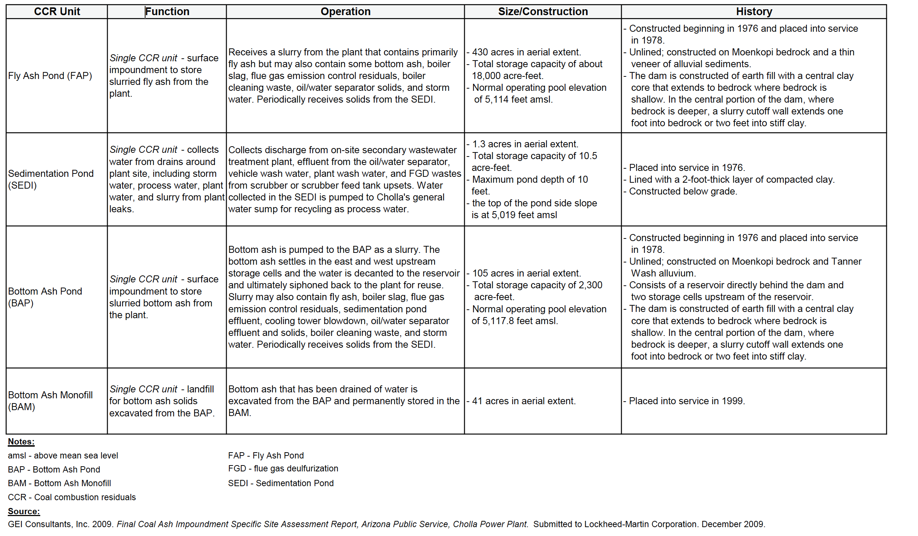

At Cholla Power Plant, there are four CCR Units. The Bottom Ash Pond has a high hazard rating and the following levels of contaminants above drinking water standards: Arsenic (x3), Boron (x12), Cobalt (x8), Fluoride (x1), Lithium (x17), Molybdenum (x9), Radium (x2), Selenium (x2), Sulfate (x23). In the Bottom Ash Pond, there is toxic metal contamination from cobalt and lithium. This unlined unit contains about 2.9 million tons of coal ash, and will be closed in place. It is subject to groundwater cleanup requirements due to high levels of cobalt and lithium. It violates the aquifer location restriction (it is located within 5 feet of groundwater).

The Fly Ash Pond has a high hazard rating and the following levels of contaminants above drinking water standards: Arsenic (x3), Boron (x12), Cobalt (x8), Fluoride (x1), Lithium (x17), Molybdenum (x9), Radium (x2), Selenium (x2), Sulfate (x23). In the Fly Ash Pond, there is toxic metal contamination from arsenic, cobalt, fluoride, lithium, and molybdenum. This unlined unit contains over 11 million tons of coal ash, and will be closed in place. It is subject to groundwater cleanup due to arsenic, cobalt, fluoride, lithium, and molybdenum. It violates the aquifer location restriction (it is located within 5 feet of groundwater).

The SEDI unit (sedimentation pond, cooling pond) has a significant hazard rating and the following levels of contaminants above drinking water standards: Arsenic (x3), Boron (x12), Cobalt (x8), Fluoride (x1), Lithium (x17), Molybdenum (x9), Radium (x2), Selenium (x2), Sulfate (x23). The SEDI surface impoundment unit is unlined and contains 3.5 million tons of coal ash and will be closed in place. The table below summarizes contaminants above EPA drinking standards across the different units at FCPP.

Table: Cholla Power Plant contaminants above EPA drinking standards
 | Arsenic | Boron | Cobalt | Fluoride | Lithium | Molybdenum | Radium | Selenium | Sulfate
Bottom Ash Pond | x3 | x12 | x8 | x1 | x17 | x9 | x2 | x2 | x23
The Fly Ash Pond | x3 | x12 | x8 | x1 | x17 | x9 | x2 | x2 | x23
SEDI unit | x3 | x12 | x8 | x1 | x17 | x9 | x2 | x2 | x23

The Bottom Ash Monofill unit does not have a hazard rating since disposal requirements only apply to surface impoundments, not landfills. This landfill does not have aquifer requirements.
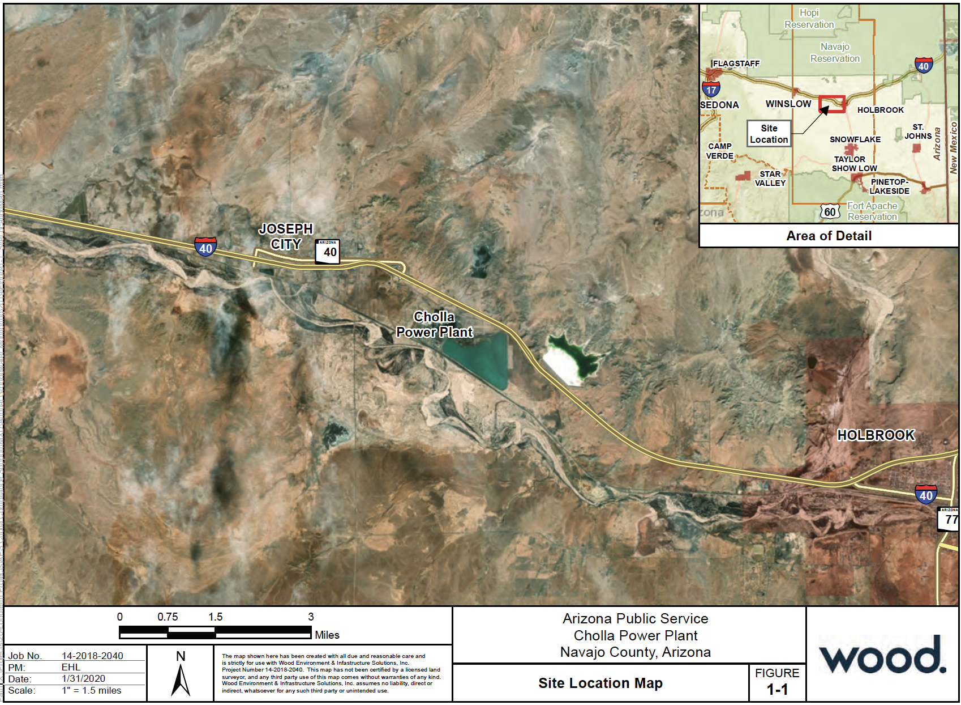
Source: 2019 CCR Compliance Report

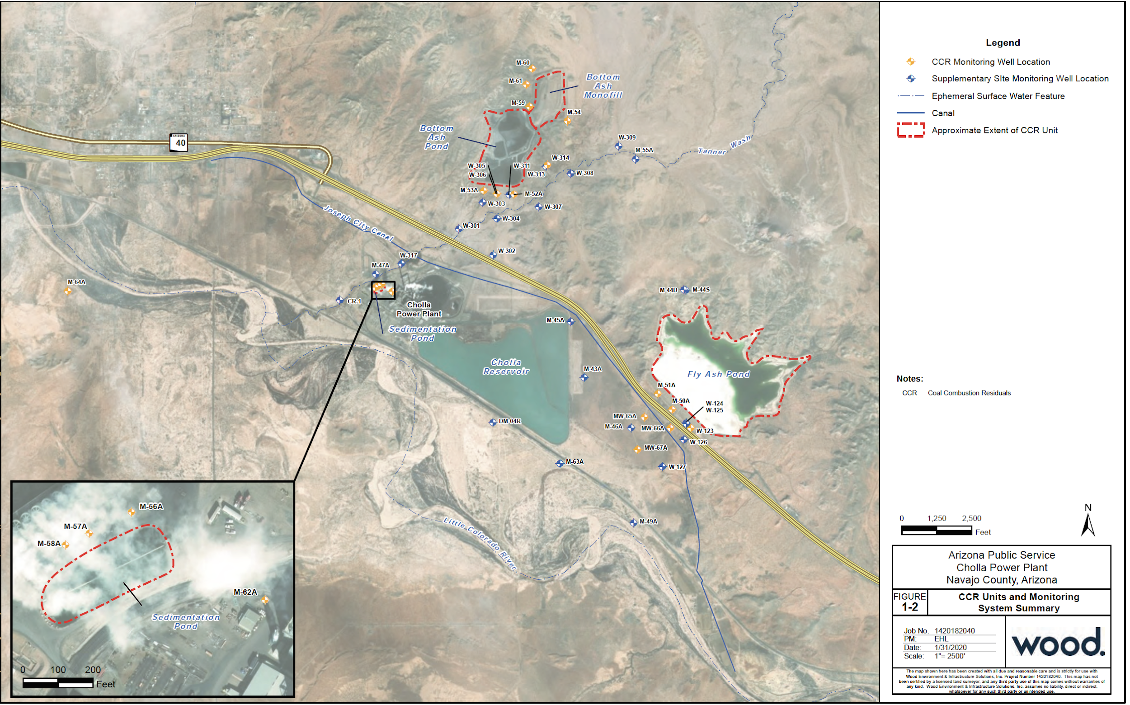

Source: 2019 CCR Compliance Report

Escalante
Escalante power plant is a 270 MW power plant with four units. Escalante power plant contains one unit that is a CCR landfill. The plant generates fly ash, bottom ash, and flye gas desulfurization (FGD) and disposes these materials in the facility. Filling began at the facility in 2009, and CCRs have been deposited over approximately 24 acres to date. The total facility footprint is approximately 54 acres. Placement of CCRs commenced at the east end of the facility and is progressing westward as design grades or interim grades are reached. As the height of the fill increases, CCRs are being placed such that they abut (“piggy back”) the inactive CCR disposal facility on the north end. The outer embankment slopes for the facility are designed at a slope ratio of 3 horizontal to 1 vertical.

This does not have a hazard rating since disposal requirements only apply to surface impoundments, not landfills. This landfill contains the following levels of contaminants above drinking water standards: Arsenic (x2), Lithium (x15). This unit contains about 800,000 tons of coal ash and does not have aquifer requirements. Groundwater contamination is unknown and this landfill does not have aquifer requirements.

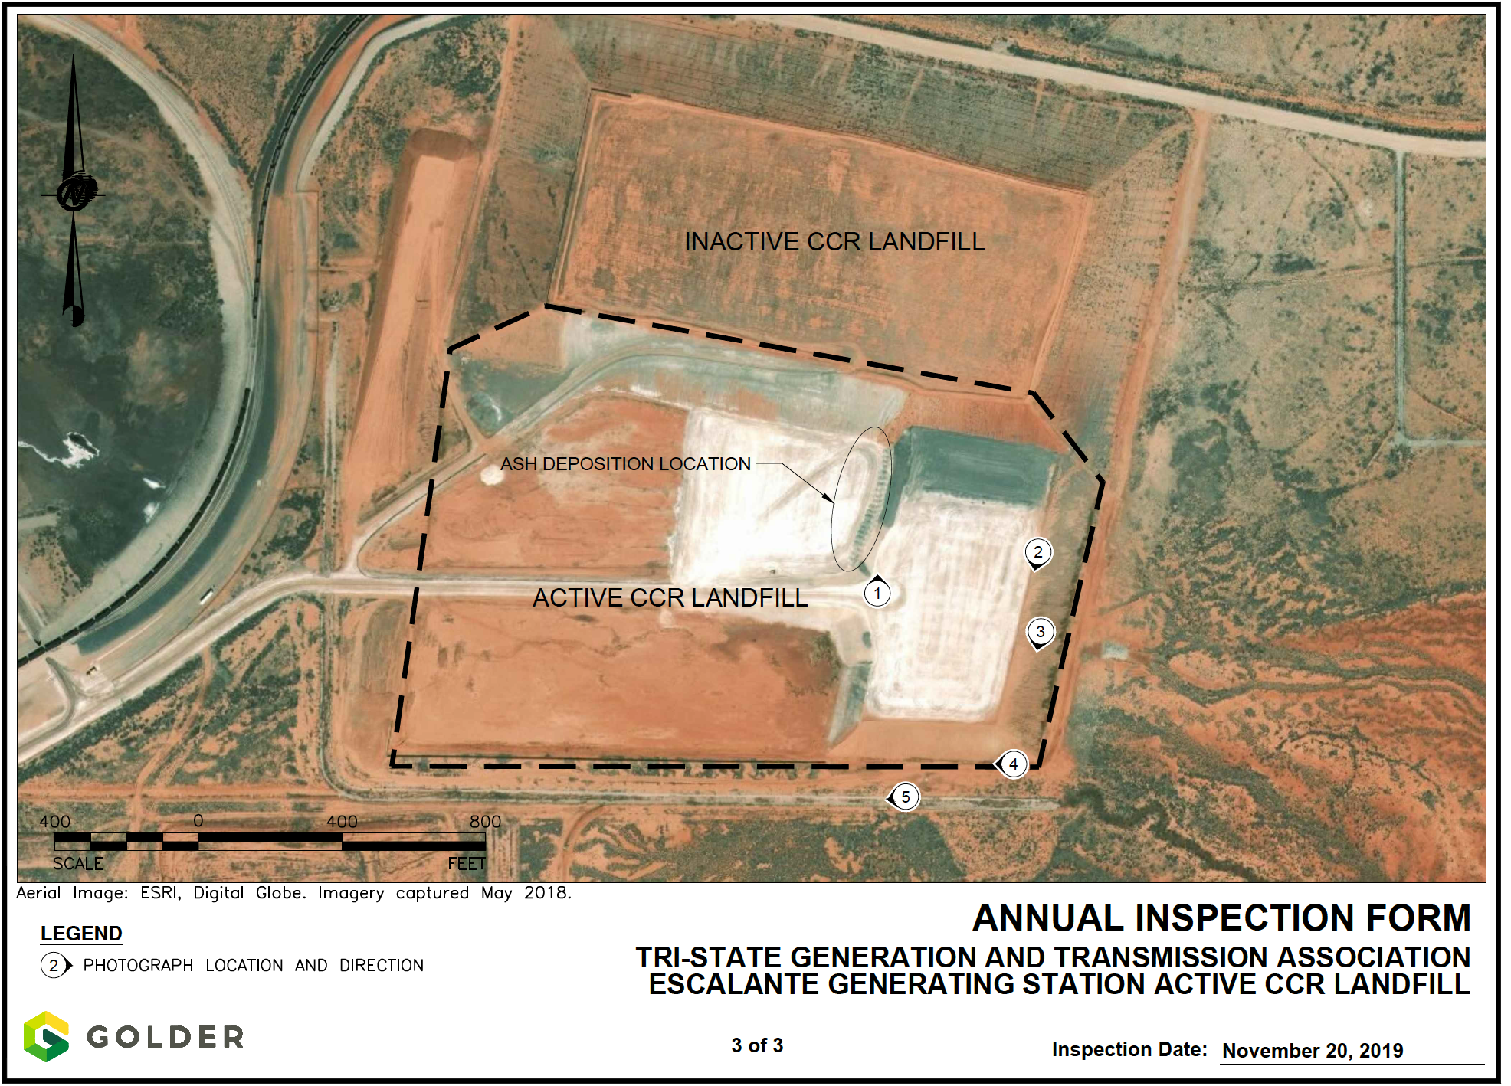
Source: 2020 CCR Annual Inspection Report

The groundwater monitoring system for the active CCR landfill at Escalante Generating Station consists of six monitoring wells.

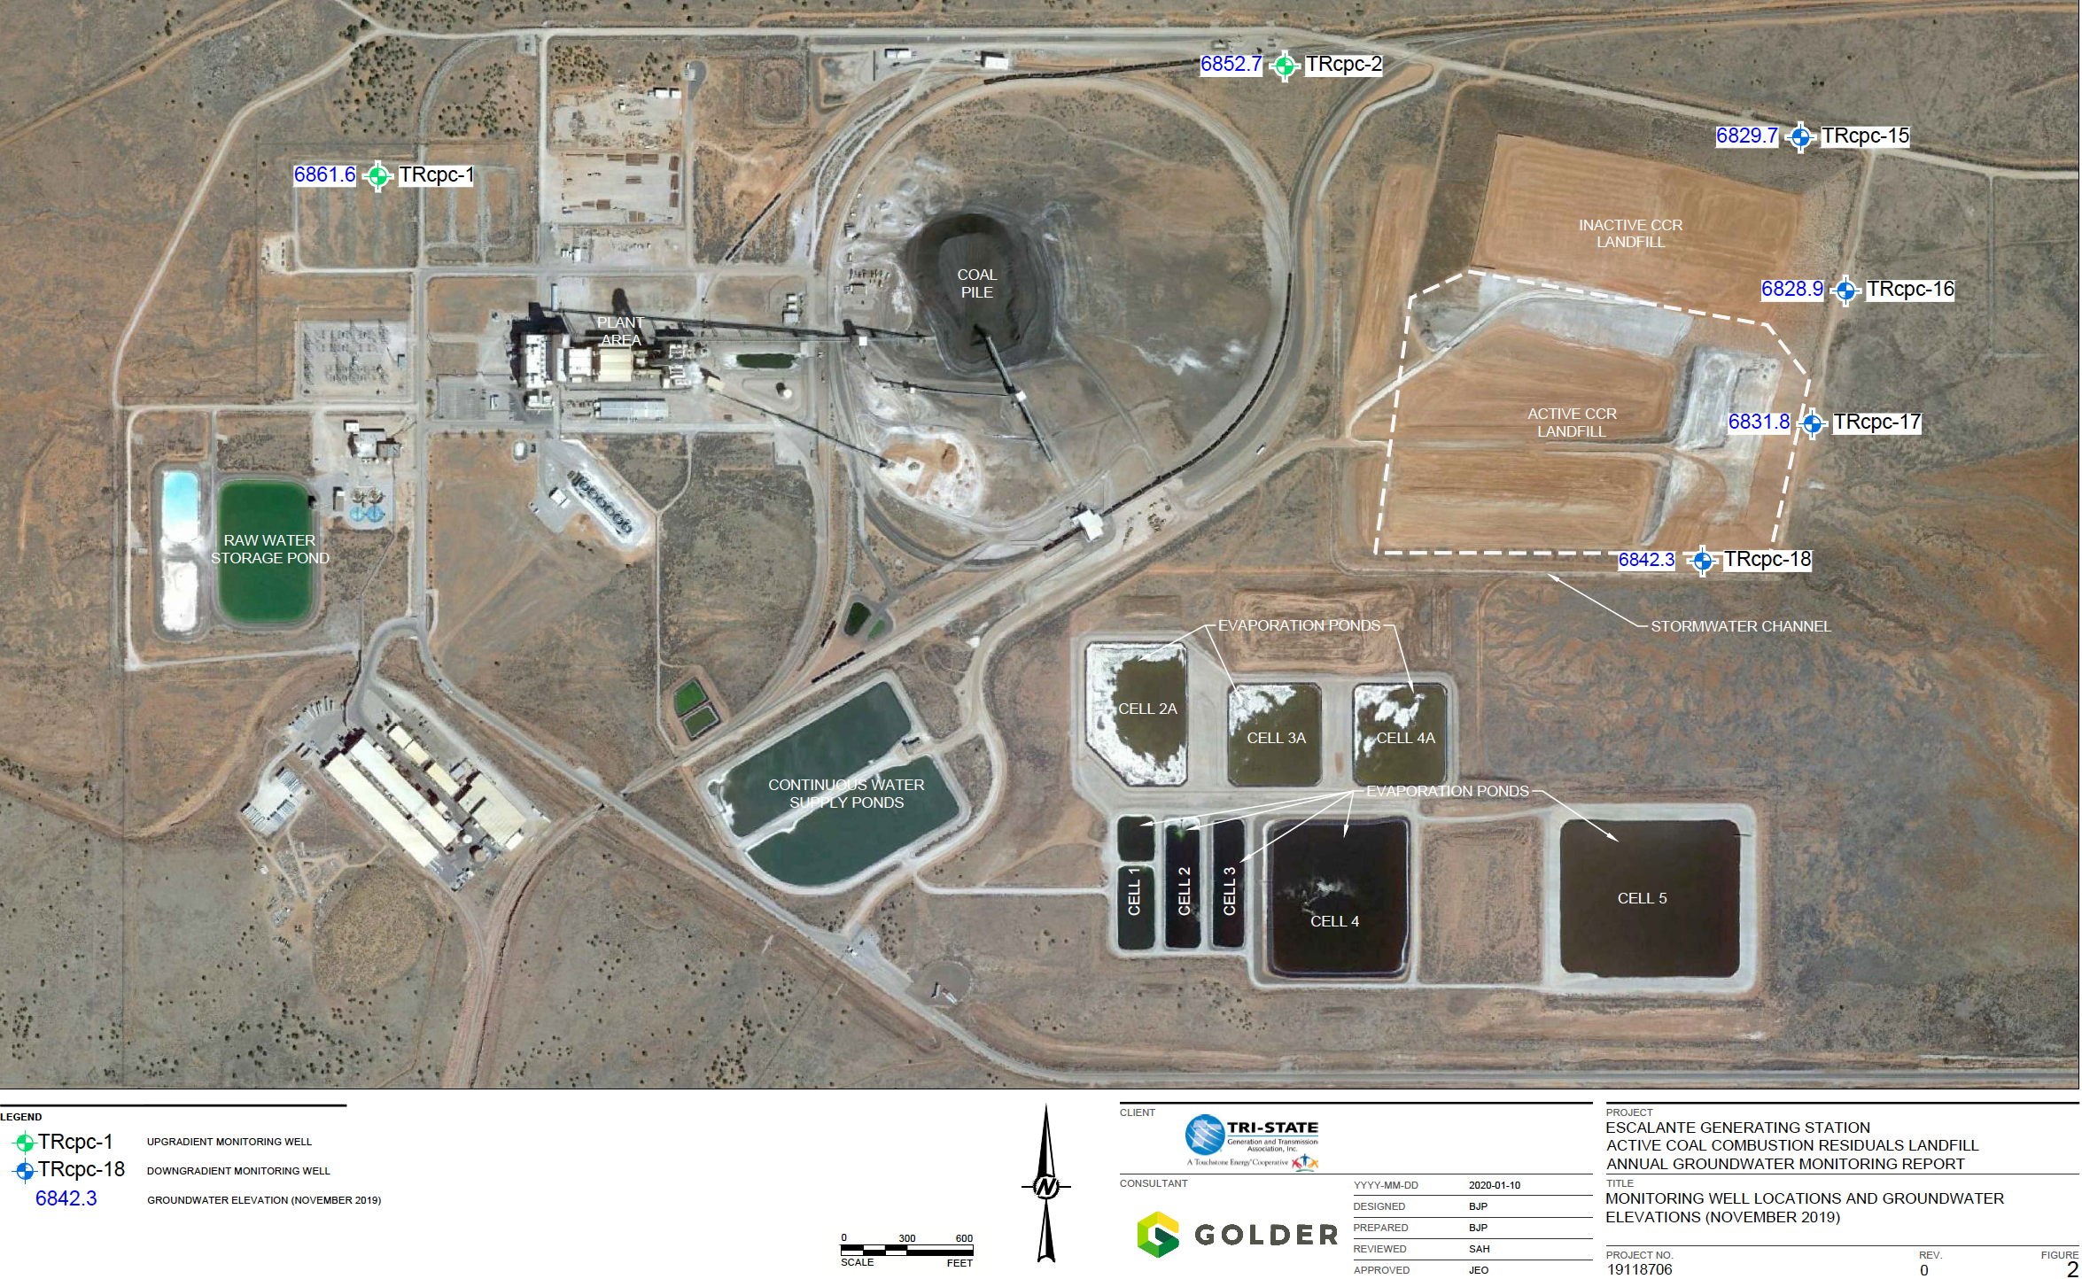
Source: 2020 Annual Groundwater Monitoring Report

The following table summarizes the results of contaminants found in the 2019 assessment.

Table: Statistics Summary for 2019 Annual Inspection
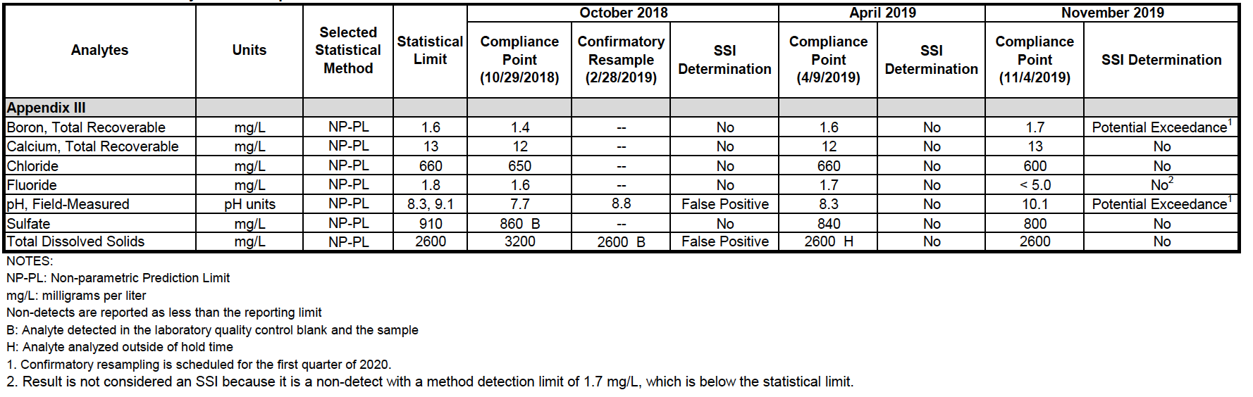

According to the inspection report by Golder done for Tri-State, the deposition area, embankment crest, embankment slopes, embankment toe, and stormwater controls were all observed to be in “good” condition. “Good” condition is defined as, “a condition that is generally better than the minimum expected condition based on the design criteria and maintenance performed at the facility.”

“Coal Ash: Hazardous for Human Health.” Prepared by the Physicians for Social Responsibility https://www.psr.org/wp-content/uploads/2018/05/coal-ash-hazardous-to-human-health.pdf
“Ash in Lungs: How Breathing Coal Ash is Hazardous to Your Health.” Prepared for Earthjustice. July, 2014. https://earthjustice.org/sites/default/files/files/Ash_In_Lungs_1.pdf
“Mapping the Coal Ash Contamination.” Prepared by Earthjustice. October, 2020. https://earthjustice.org/features/map-coal-ash-contaminated-sites
“Mapping the Coal Ash Contamination.” Prepared by Earthjustice. October, 2020. https://earthjustice.org/features/map-coal-ash-contaminated-sites
“Mapping the Coal Ash Contamination.” Prepared by Earthjustice. October, 2020. https://earthjustice.org/features/map-coal-ash-contaminated-sites
“Coal Ash Basics” Prepared for the United States Environmental Protection Agency. https://www.epa.gov/coalash/coal-ash-basics
“Coal Ash Basics” Prepared for the United States Environmental Protection Agency. https://www.epa.gov/coalash/coal-ash-basics
“Mapping the Coal Ash Contamination.” Prepared by Earthjustice. October, 2020. https://earthjustice.org/features/map-coal-ash-contaminated-sites
Lemly (2012). A Dennis Lemly and Joseph P. Skorupa, Wildlife and the Coal Waste Policy Debate: Proposed Rules for Coal Waste Disposal Ignore Lessons from 45 Years of Wildlife Poisoning, Environ. Sci. Technol. 2012, 46, 8595−8600.
Proposed Site-Specific Selenium Criterion, Sage and Crow Creeks, Idaho, January 2012. Prepared for J.R. Simplot Company by: Formation Environmental, LLC and HabiTech, Inc. Submitted by J.R. Simplot Co. to Idaho Department of Environmental Quality on January 30, 2012. Appendix C of Appendix D.
“The Coal Ash Problem.” Prepared by Earthjustice https://earthjustice.org/features/the-coal-ash-problem
“Ash in Lungs: How Breathing Coal Ash is Hazardous to Your Health” Prepared for Earthjustice. July, 2014. https://earthjustice.org/sites/default/files/files/Ash_In_Lungs_1.pdf
“Ash in Lungs: How Breathing Coal Ash is Hazardous to Your Health” Prepared for Earthjustice. July, 2014. https://earthjustice.org/sites/default/files/files/Ash_In_Lungs_1.pdf
“Coal Ash: Hazardous for Human Health” Prepared by the Physicians for Social Responsibility https://www.psr.org/wp-content/uploads/2018/05/coal-ash-hazardous-to-human-health.pdf
“Ash in Lungs: How Breathing Coal Ash is Hazardous to Your Health” Prepared for Earthjustice. July, 2014. https://earthjustice.org/sites/default/files/files/Ash_In_Lungs_1.pdf
“Ash in Lungs: How Breathing Coal Ash is Hazardous to Your Health” Prepared for Earthjustice. July, 2014. https://earthjustice.org/sites/default/files/files/Ash_In_Lungs_1.pdf
Valencic, Aaron. “Dust Suppression in Coal Ash Applications,” 2013 World of Coal Ash (WOCA) Conference, Lexington, KY, available at http://www.flyash.info/2013/098-Valencic-2013.pdf.
“Ash in Lungs: How Breathing Coal Ash is Hazardous to Your Health” Prepared for Earthjustice. July, 2014. https://earthjustice.org/sites/default/files/files/Ash_In_Lungs_1.pdf
According to EPA, fly ash has a typical radiation level between a low of 2 pCi/g and a high of 9.7 pCi/g. See http:// www.epa.gov/radiation/tenorm/coalandcoalash.html
Figure 1. Graph from Radioactive Elements in Coal and Fly Ash: Abundance, Forms, and Environmental Significance. U.S. Geological Survey Fact Sheet FS-163-97. October, 1997.
“Ash in Lungs: How Breathing Coal Ash is Hazardous to Your Health” Prepared for Earthjustice. July, 2014. https://earthjustice.org/sites/default/files/files/Ash_In_Lungs_1.pdf
Agency for Toxic Substances and Disease Registry, Division of Toxicology and Environmental Medicine ToxFAQs, Hydrogen Sulfide, CAS #7783-06-4, July 2006.
“Ash in Lungs: How Breathing Coal Ash is Hazardous to Your Health” Prepared for Earthjustice. July, 2014. https://earthjustice.org/sites/default/files/files/Ash_In_Lungs_1.pdf
Edison Electric Institute, Silica Exposure at Electric Utilities, EEI Safety and Health Webinar, July 22, 2009, 8, available at http://www3.eei.org/meetings/ Meeting%20Documents/2009-07-22-IHIssuesWeb- Silica_Hatcher.pdf.
Barry Breen, Acting Assistant Administrator, Office of Solid Waste and Emergency Response, US EPA. Testimony delivered to Committee on Transportation and Infrastructure, Subcommittee on Water Resources and the Environment, U.S. House of Representatives, April 30, 2009.
U.S. Environmental Protection Agency (EPA), “Human and Ecological Risk Assessment of Coal Combustion Wastes” (draft). (Released as part of a Notice of Data Availability) Aug. 6, 2007.
“Human and Ecological Risk Assessment of Coal Combustion Wastes. Draft document.” Prepared for U.S. Environmental Protection Agency, Office of Solid Waste. 2007. http://www.publicintegrity.org/assets/pdf/CoalAsh-Doc2.pdf
“Coal’s Poisonous Legacy: Groundwater Contaminated by Coal Ash Across the U.S.” Prepared by The Environmental Integrity Project. March, 2019. https://earthjustice.org/sites/default/files/files/national-coal-ash-report-7.11.19.pdf
“Coal Ash Basics” Prepared for the United States Environmental Protection Agency. https://www.epa.gov/coalash/coal-ash-basics
Proposed Site-Specific Selenium Criterion, Sage and Crow Creeks, Idaho, January 2012. Prepared for J.R. Simplot Company by: Formation Environmental, LLC and HabiTech, Inc. Submitted by J.R. Simplot Co. to Idaho Department of Environmental Quality on January 30, 2012. Appendix C of Appendix D.
Lemly, A. Dennis. 2002. Symptoms and implications of selenium toxicity in fish: the Belews Lake case example. Aquatic Toxicology 57 (2002) 39 49
Laura Ruhl, Avner Vengosh, Gary S. Dwyer, Heileen Hsu-Kim, and Amrika Deonarine Environmental Science & Technology 2010 44 (24), 9272-9278 DOI: 10.1021/es1026739
A. Dennis Lemly, Damage cost of the Dan River coal ash spill, Environmental Pollution, Volume 197, 2015, Pages 55-61, ISSN 0269-7491, https://doi.org/10.1016/j.envpol.2014.11.027
Rowe, C.L., Hopkins, W.A. & Congdon, J.D. Ecotoxicological Implications of Aquatic Disposal of Coal Combustion Residues In the United States: A Review. Environ Monit Assess 80, 207–276 (2002). https://doi.org/10.1023/A:1021127120575
“Conservation Groups’ Comments on the Draft Environmental Impact Statement for the Four Corners Power Plant and Navajo Mine Energy Project” 2014. Western Environmental Law Center.
“Evaluation and Professional Opinions Regarding Geological and Hydrogeologic Aspects of the 2016 Draft Environmental Impact Statement as it Pertains to Scheduled Facility Closure in 2019 or Extending Operation Until 2044.” 2017. Groundwater Management Associates.
“Evaluation and Professional Opinions Regarding Geological and Hydrogeologic Aspects of the 2016 Draft Environmental Impact Statement as it Pertains to Scheduled Facility Closure in 2019 or Extending Operation Until 2044.” 2017. Groundwater Management Associates.
Evaluation and Professional Opinions Regarding Geological and Hydrogeologic Aspects of the 2016 Draft Environmental Impact Statement as it Pertains to Scheduled Facility Closure in 2019 or Extending Operation Until 2044.” 2017. Groundwater Management Associates.
Salt River Project Agricultural Improvement and Power District (SRP), 2016b, Draft Environmental Impact Statement, Navajo Generating Station-Kayenta Mine Complex Project, Appendicies, 1094 pages
“Evaluation and Professional Opinions Regarding Geological and Hydrogeologic Aspects of the 2016 Draft Environmental Impact Statement as it Pertains to Scheduled Facility Closure in 2019 or Extending Operation Until 2044.” 2017. Groundwater Management Associates.
“2019 Annual Groundwater Monitoring and Corrective Action Report: Ash Landfill, Navajo Generating Station Page, Arizona.” 2019. Prepared for Salt River Project by Haley & Aldrich, Inc.
“2019 Annual Groundwater Monitoring and Corrective Action Report: Ash Landfill, Navajo Generating Station Page, Arizona.” 2019. Prepared for Salt River Project by Haley & Aldrich, Inc.
Salt River Project Agricultural Improvement and Power District (SRP), 2016a, Draft Environmental Impact Statement, Navajo Generating Station-Kayenta Mine Complex Project, Text, 1652 pages
Sierra Club, Press Release: “Sierra Club Releases Report Showing The Dangers Of Coal Ash At The Four Corners Power Plant Sierra Club cites Arizona Public Service coal ash storage sites among the worst in the country” (May 15, 2014) (available at: http://content.sierraclub.org/press-releases/2014/05/sierra-club-releases-report-showing-dangers-coal-ash-four-corners-power-plant
URS letter to NM OSE at 1 (June 23, 2011)
“Technical Memorandum Regarding Hydrological Impacts from the Disposal of Coal Combustion Residuals (CCRs) at Four Corners Power Plant, New Mexico, Navajo Nation.” 2020. Steve Campbell, PhD.
https://www.sanjuancitizens.org/four-corners-power-plant-navajo-mine)
Wood Environment & Infrastructure Solutions, Inc. (Wood), 2020, Annual Groundwater Monitoring and Corrective Action Report for 2019, Coal Combustion Residuals Rule Groundwater Monitoring System Compliance, Four Corners Power Plant, Fruitland, New Mexico, (dated 1/31/2020), Page 3 of Appendix A
Technical Memorandum Regarding Hydrological Impacts from the Disposal of Coal Combustion Residuals (CCRs) at Four Corners Power Plant, New Mexico, Navajo Nation.” 2020. Steve Campbell, PhD.
Arizona Public Service Company (APS), 2013b, Cover letter to USEPA (dated 4/3/2013) transmitting the Four Corner Power Plant, Geohydrogeology Data Submittal.
Technical Memorandum Regarding Hydrological Impacts from the Disposal of Coal Combustion Residuals (CCRs) at Four Corners Power Plant, New Mexico, Navajo Nation.” 2020. Steve Campbell, PhD.
Technical Memorandum Regarding Hydrological Impacts from the Disposal of Coal Combustion Residuals (CCRs) at Four Corners Power Plant, New Mexico, Navajo Nation.” 2020. Steve Campbell, PhD.
Technical Memorandum Regarding Hydrological Impacts from the Disposal of Coal Combustion Residuals (CCRs) at Four Corners Power Plant, New Mexico, Navajo Nation.” 2020. Steve Campbell, PhD.
Technical Memorandum Regarding Hydrological Impacts from the Disposal of Coal Combustion Residuals (CCRs) at Four Corners Power Plant, New Mexico, Navajo Nation.” 2020. Steve Campbell, PhD.
The Office of Surface Mining and Reclamation Enforcement (OSMRE) San Juan Deep Lease Extension Final EIS. March 2019.
The Office of Surface Mining and Reclamation Enforcement (OSMRE) San Juan Deep Lease Extension Final EIS. March 2019.
The Office of Surface Mining and Reclamation Enforcement (OSMRE) San Juan Deep Lease Extension Final EIS. March 2019.
The Office of Surface Mining and Reclamation Enforcement (OSMRE) San Juan Deep Lease Extension Final EIS. March 2019.
“Waste Deep: Filling Mines is Profit for Industry, but Poison for People.” Prepared by Earthjustice https://earthjustice.org/sites/default/files/library/reports/earthjustice_waste_deep.pdf
“Active Coal Combustion Residuals Landfill Annual Inspection- Escalante Generating Station.” 2020. Prepared by Golder Associates Inc for Tri-State Generations and Transmission Association, Inc.
“Active Coal Combustion Residuals Landfill Annual Inspection- Escalante Generating Station.” 2020. Prepared by Golder Associates Inc for Tri-State Generations and Transmission Association, Inc.
“Annual Groundwater Monitoring Report- 2019: Active coal Combustion Residuals Landfill Escalante Generating Station, Prewitt, New Mexico. 2020. Prepared by Golder Associates, Inc. for Tri-State Generation and Transmission Association, Inc.
“Annual Groundwater Monitoring Corrective Action Report for 2019: Coal Combustion Rule Groundwater Monitoring System Compliance Cholla Power Plant, Navajo County, Arizona” 2020. Prepared by Wood Environmental & Infrastructure Solutions, Inc. for APS.
“Trump Administration Wages Multifront Assault on Coal Ash Protections.” Prepared by Earthjustice/ March, 2020.
“Waste Deep: Filling Mines is Profit for Industry, but Poison for People.” Prepared by Earthjustice https://earthjustice.org/sites/default/files/library/reports/earthjustice_waste_deep.pdf
Ecosphere (Ecosphere Environmental Services). 2017. Deep Lease Extension Project San Juan Mine Baseline Data Summary Report Groundwater Resources. March. Prepared for the San Juan Coal Company
“Evaluation and Professional Opinions Regarding Geological and Hydrogeologic Aspects of the 2016 Draft Environmental Impact Statement as it Pertains to Scheduled Facility Closure in 2019 or Extending Operation Until 2044.” 2017. Groundwater Management Associates.
Ecosphere (Ecosphere Environmental Services). 2017. Deep Lease Extension Project San Juan Mine Baseline Data Summary Report Groundwater Resources. March. Prepared for the San Juan Coal Company
“Coal’s Poisonous Legacy: Groundwater Contaminated by Coal Ash Across the U.S.” Prepared by The Environmental Integrity Project. March, 2019. https://earthjustice.org/sites/default/files/files/national-coal-ash-report-7.11.19.pdf
“Coal’s Poisonous Legacy: Groundwater Contaminated by Coal Ash Across the U.S.” Prepared by The Environmental Integrity Project. March, 2019. https://earthjustice.org/sites/default/files/files/national-coal-ash-report-7.11.19.pdf

